Oral Storytelling Lessons and Tips

Meg Campbell
Preservation Trust of Vermont and Vermont Story Lab

Three most important things I have learned:

1) Being comfortable and relaxed is really important for both me and the person I am interviewing. Spending time visiting and talking beforehand makes a big difference. Explaining that we should think of it not as an interview but as a conversation — it helps us both be at ease.

2) Asking good questions in the right way is also really important. (Mine are not actually questions but rather dialogue prompts.) For example, instead of “Who uses this building?” I’d say “Paint a picture for me of the populations that might come through the door on a yearly basis”. People like to paint pictures with their words, and it helps them think visually about their answers as opposed to reciting a bulleted list. Another example: instead of “How does the community feel about the building?” I’d say “Help me understand how the community feels about this building.” This invites a longer and more thoughtful response.

3) Being patient is critical. I’ve learned to keep my mouth shut and let them talk, be silent, and make the space for them to talk some more. Usually what comes after the first phase of words is where the gems are hiding. It’s like the second batch of pancakes.

Another really interesting thing I’ve discovered and enjoyed immensely is listening to Krista Tippet’s On Being interviews. She has both the unedited and edited versions on Sound Cloud. Listening to one and then the other makes it apparent that even really good interviewers have really good editors, and there is much to learn about what that means by listening to both.

As far as tips, all of the above plus these which really are part of recording :

1) Don’t use verbal responses as they are answering because they are very tough to edit out.

2) A good recorder and/or microphone is really important

3) Don’t be shy about asking additional questions, getting them to elaborate, or answer the same question again if it didn’t come out right. It’s tough if not impossible to go back to that moment.

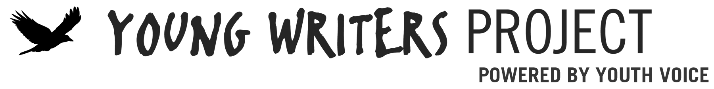

Ideas for Oral Storytelling

YWP’s philosophy on writing is based on the assumption that we are natural storytellers and that all good writing is narrative. As with any type of writing, it is important that you do a little self-reflection to ask yourself: What are my best stories and what makes them good? How can they be better? Where am I most comfortable in telling those stories?

Against that backdrop, here are few ideas to help you tell stories well:

- Write first. While many people are afraid of writing, or feel they’re no good at it, this is where good oral stories begin. Write your favorite story. Do it QUICKLY. Don’t think about it too much. AND imagine that you are writing it for someone who really appreciates you but does not judge you, someone you trust.
- Edit. Great writing is the result of great revision. Print out what you’ve written and get a sharp pencil. Look it over in respect to these questions:
  - Does the piece have all the elements needed? (Hint: You or your main character has to have a want or a need, an obstacle that prevents the character from attaining the want/need and some kind of resolution. A story is a problem that gets resolved.)
  - Is it in your voice? (Hint: Go some place private and read it aloud. Is it you? And fix wherever your tongue gets fouled up in reading it aloud.)
  - Is it interesting? (Hint: We often include too much background and try to tie up too many loose ends. Follow this old writing maxim: Edit your story so that it starts later than you think it should and ends sooner than you think it should.)
  - Can you see yourself telling this in public? (Hint: This is about confidence; if you can’t see yourself telling it to others, you need to look at what aspects are making you nervous. Fix them.)
- Practice. Even if you are just planning to record your story to post it somewhere, practice telling it; get so that it no longer sounds like you are reading. Imagine yourself in your favorite place, the place where you feel you are most you. Cut more of your story as you go to keep the story line strong and the tangents important. Are you liking the story more? You have to love your story, have confidence in your story, to tell it well.
- Go for it. It will never be perfect. Set aside your writing and go tell it to someone. Tell it to a group. See what people react to. Learn what your audience thinks. Each experience will show you how to make little changes – little additions and subtractions – to get it to where you feel it works.

– Geoffrey Gevalt
YWP Founder

