Digital Storytelling for Nonprofits
A Vermont Community Foundation Workshop

Barbara Ganley of Community Expressions, LLC
& Special Guest Meg Campbell of The Preservation Trust of Vermont
March 25, 2015

**Workshop Resources & Slides: http://community-expressions.com/resources-3/digital-storytelling-for-nonprofits-2/

Questions? Contact Us:

Barbara barbaraganley@gmail.com Meg meg@ptvermont.org
(802)989-1885 (802) 442-8951
Twitter: @bgblogging Twitter: @preservationvt

Agenda

Hour One
Laying the Groundwork: Good Stories, Great Stories
Telling Stories, Listening
Diving Right In

Hour Two
Digital Storytelling -- Not the Same Old Story
The Visual in Digital:
Transforming your Newsletters, Annual Reports and Emails
Trying Out Visual Stories

Ten-Minute Break

Hour Three
Social Media and Storytelling:
The Case for Blogging & Facebook
A Look at Twitter & Instagram

Hour Four
Becoming A Storytelling Organization:
First Steps to A Storytelling Strategy
Story Culture within Your Org
Building a Story Bank
What Next
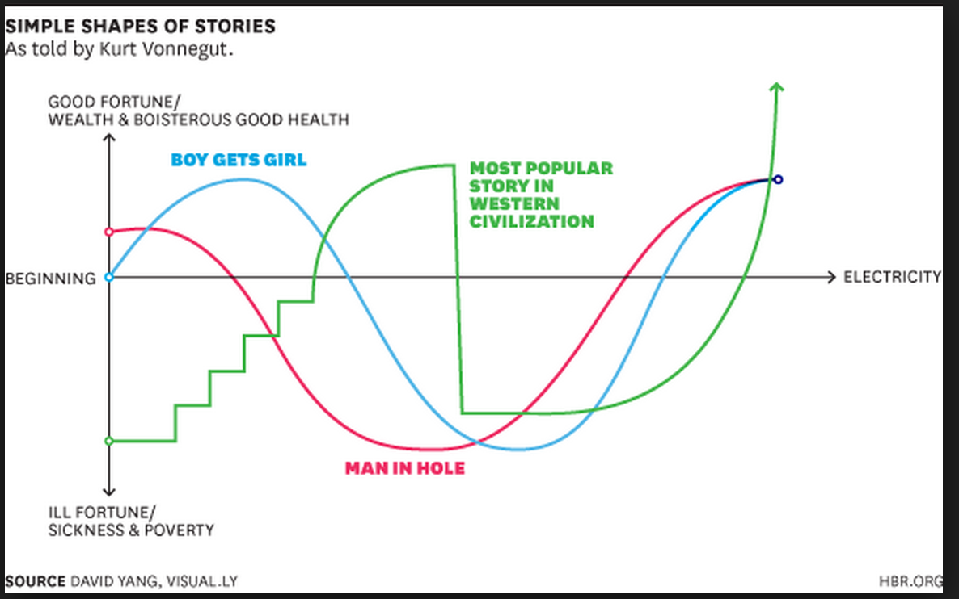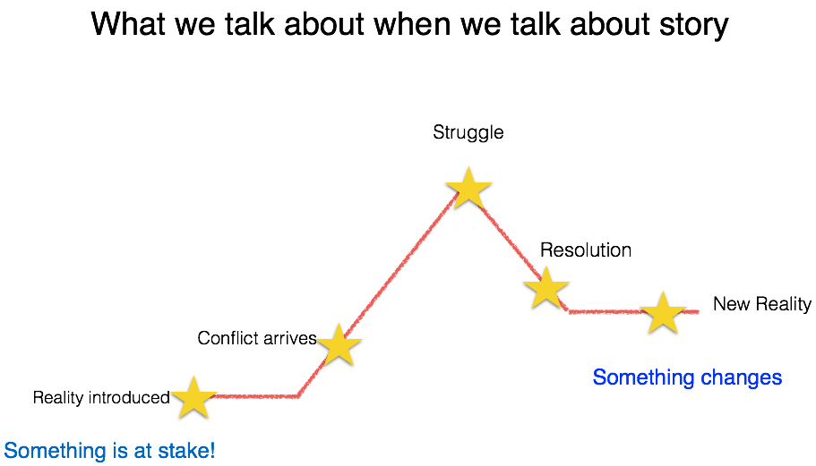

Plan a one-minute story about someone your nonprofit has touched (a donor, staff member, yourself, board member, client, community member)

Are you avoiding these
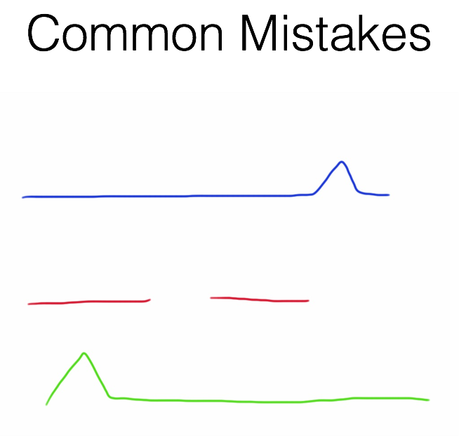

Blogging Exercise

- What value might blogging or long-form storytelling bring to your organization?

- Who would be the target audience?

- Who might contribute a post?

- Come up with one long post topic, one short.

- How might you use visuals for these two posts?

Facebook Exercise

- Who should you be reaching (better) through FB?

- Action Steps: How might you get them to do more than read your posts? What would you like them to do?

- What larger visual narrative could you build through smaller stories?

- How are you weaving Facebook in with your other social media, newsletters, website? Are you repurposing your content?

- Come up with ideas for two Facebook posts you could do tomorrow.

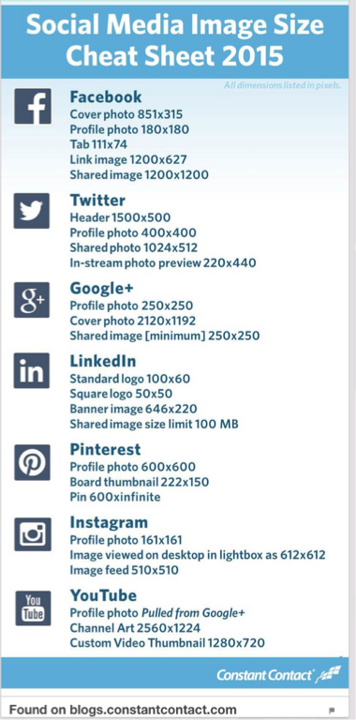

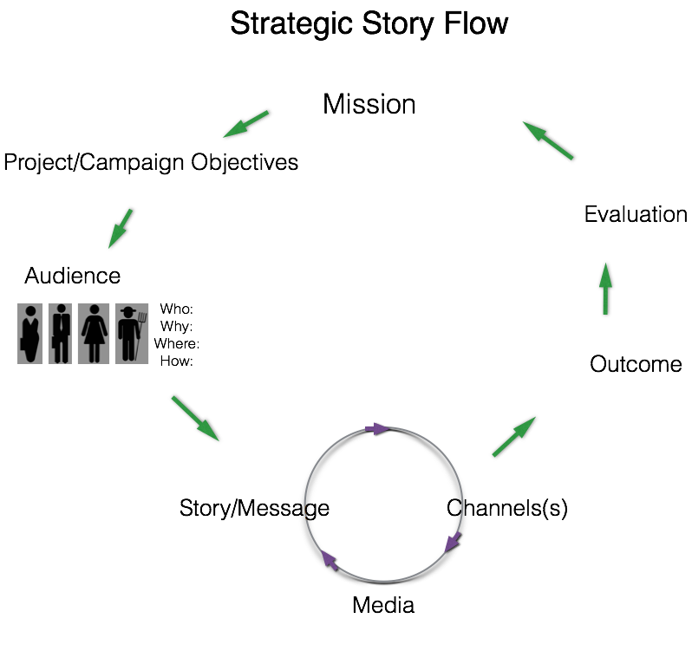

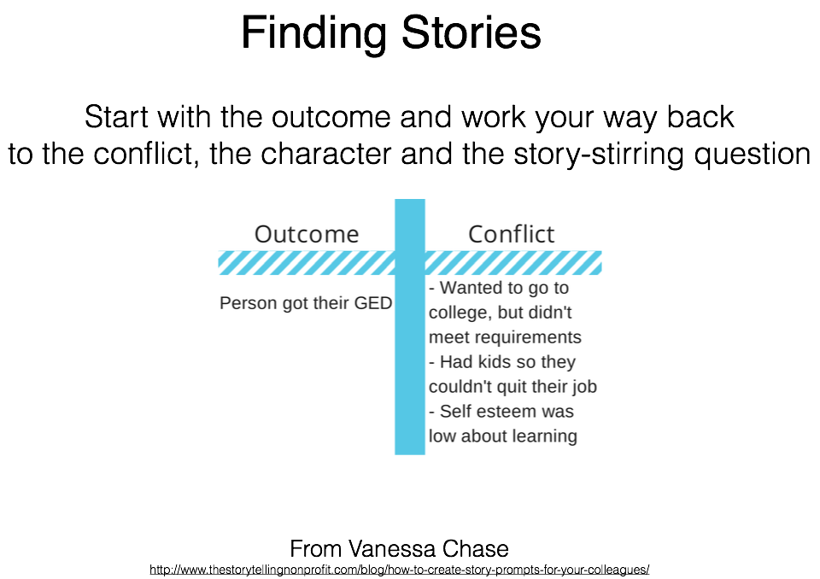

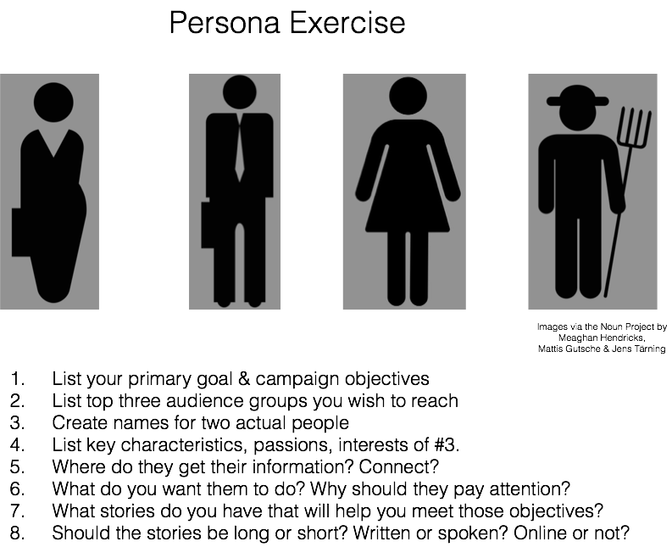

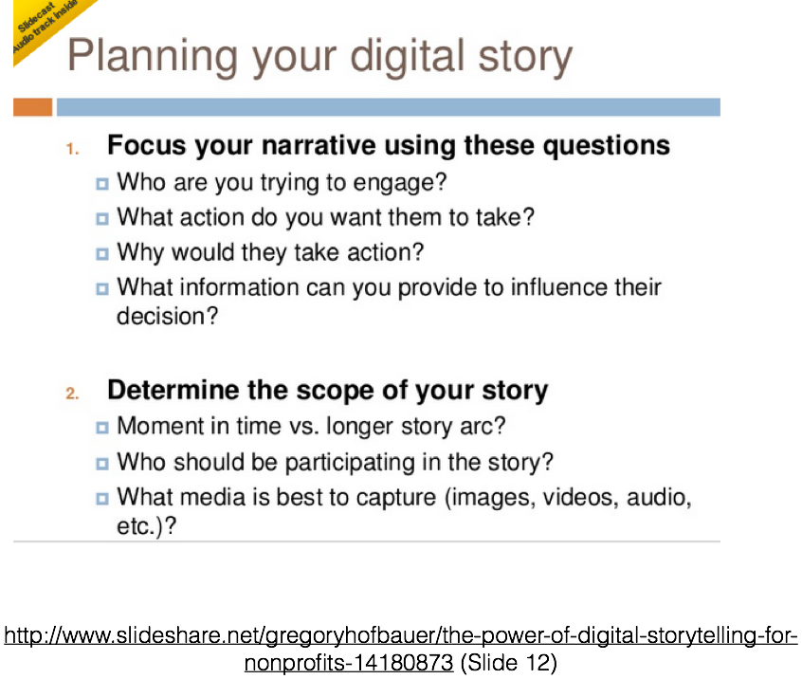

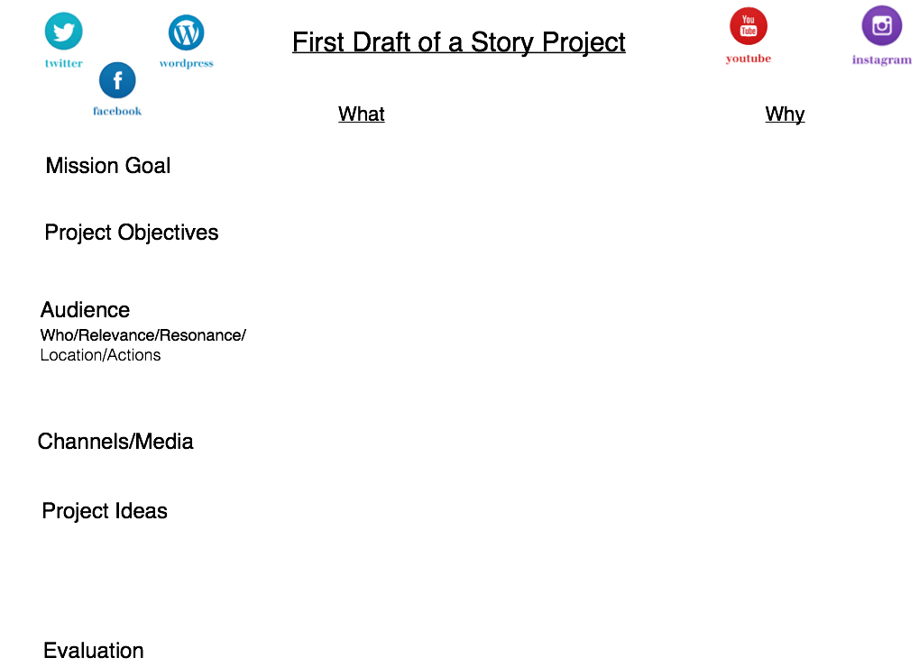

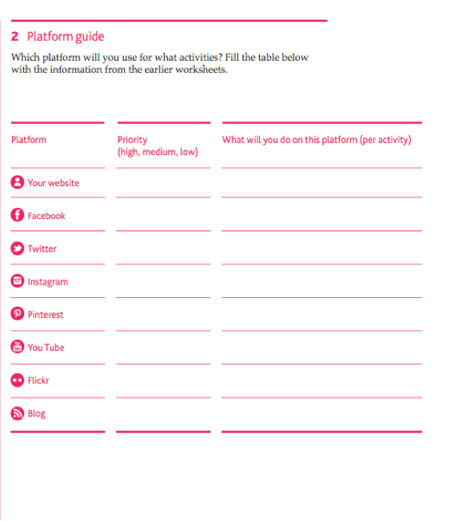
From Digital Engagement Booklet by Jasper Visser & Jim Richardson http://digitalengagementframework.com/

Also check out HATCH for Good: https://www.hatchforgood.org/
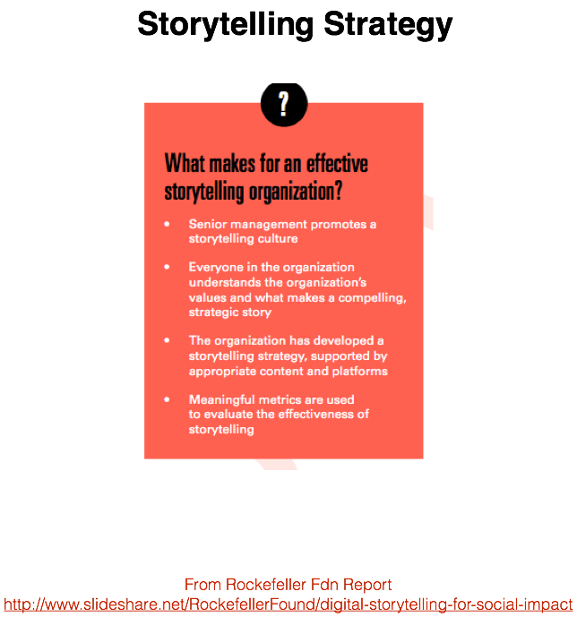

Exercise: Building Your Storytelling Organization

- One Goal, One Step, Now. Less is often more. What one strategic goal might digital storytelling help you reach? What’s the one step you can take now?

- Collaboration & Community. What will you tell your co-workers tomorrow? How will you get them to participate in digital storytelling? What help do you need from whom?

- Storytelling Strategy. Ask what for, for whom, then -- what stories, channels & media.

- Story Bank. What stories do you have? Can you repurpose them?

- Digital Channels & Media. Which channels will you focus on first? Why?

- Visual Storytelling. How will you use visuals?

- Evaluation. What will success look like and how will you know it?

