Storytelling to Build Community Workshop

Through a series of exercises we will explore ways to use storytelling to create community bonds, bridge divides, grow participation, and foster understanding.

Agenda

Hour One Stories and Community, An Overview

1. Welcome/Intro
2. Story Circles: The Story of Your Name
3. Overview Discussion/Presentation: Stories and Community: Why
4. Metaphor Exercise
5. Stories and Community: How (A Quick Tour) of Channels & Media Choices

Hour Two Finding, Sharing and Asking for Story

1. Finding Stories Exercise: Network Mapping & Community Story Banks
2. Exercise: Story Circles for Engagement: The Power of Sharing Our Community Stories
3. Overview: How and When We Ask for Stories
4. Role Play: Story Interviews

15-minute Break

Hour Three Interviews, Events and Locative Storytelling

1. Exercise: Story Interviews in Triads
2. Weaving Storytelling into Community Events Discussion & Exercise
3. Locative Storytelling Discussion & Exercise: Postcard Stories

Hour Four Digital Stories & Building a Storytelling Project

1. Digital Storytelling & Social Media for Communities: Why and Why Not
2. Scenario Stories: An Exercise
3. Building a Storytelling Project Small and Large, A Timeline Exercise
4. Final Story Circle

Factors That Give Us A Sense of Community
1) Membership
Membership comprises four attributes:
- Boundaries
- Emotional safety
- Personal investment
- A common symbol system
2) Influence
3) Integration and fulfillment of needs
4) Shared emotional connections
http://www.wright-house.com/psychology/sense-of-community.html

Communities Your Nonprofit Wishes to Build, Develop, Engage:

Why?

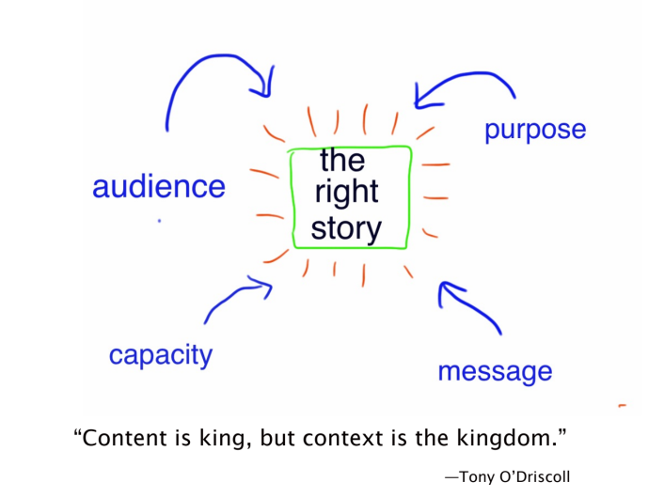

Questions to Ask Your Nonprofit Story

1. Do you know your audience, your purpose, your message? Are they aligned? Are they clear in the story?

2. Which channels are most effective for this story and audience?

3. What media will you use? Are you thinking of your audience?

4. Do you have the know-how and the capacity to bring this story to life? If you don’t, who could help you?

5. What theme does your story follow?
Overcoming Adversity
Solving a Problem
Making a Connection
Recalling the Origin
Celebrating an Event, Accomplishment, Milestone
Looking to the Future
Failing

6. Have you framed the story well – what comes before and after the story?

7. Are you emphasizing the problem or the solution?

8. Who gets to tell this story? Why?

9. Who is the hero? Is your hero memorable? Will your audience care about him/her?

10. Does the story open at the last possible moment? Have a compelling ending?

11. What is at stake in the story? Where is the tension?

12. Where is the shift, the change? Is it implied?

13. Is the story as short and simple as it could be (without loss)?

14. Is the message clear?

15. Is the language lively and appealing and jargon-free?

16. Is the story free of clichés?

17. If this story will appear on the Web, are you using the visual elements to full advantage? Does text + image = more than the sum of their parts? Is video serving your story?

Storytelling’s Role in Community

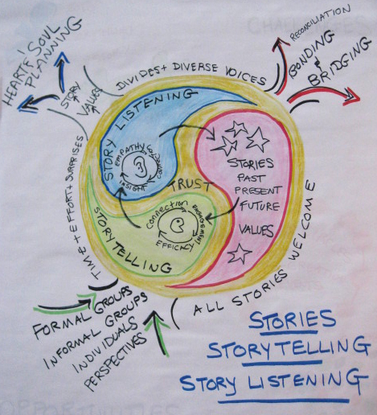

Learning from the Past & Present While Looking to the Future

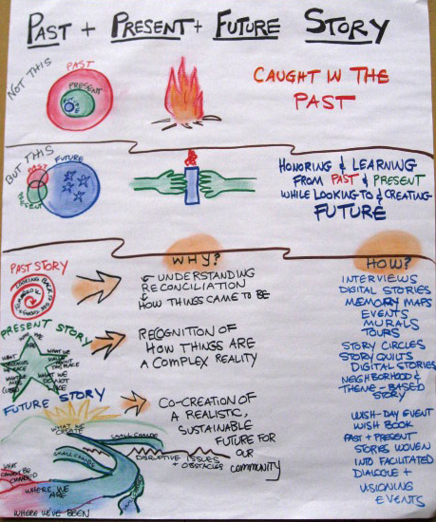
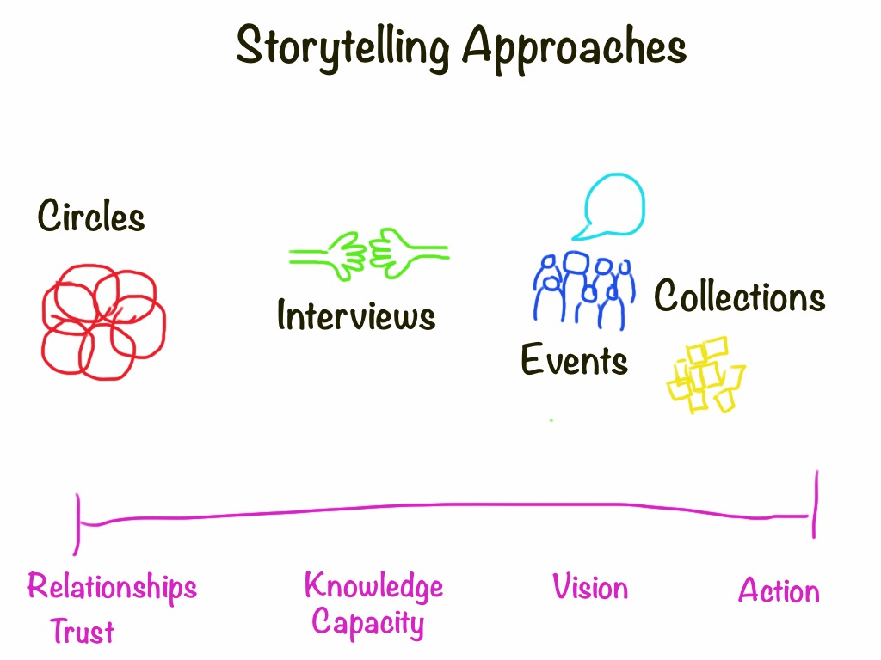

Story Channels

ONE-ON-ONE CONVERSATION
ORAL PRESENTATION/PITCH
NEWSLETTER/EMAIL
ANNUAL REPORT
GRANT APPLICATION
PRESS RELEASE
WEBSITE
SOCIAL MEDIA
FUNDRAISING APPEAL LETTER
POSTER
RADIO SPOT
TELEVISION INTERVIEW
ADVERTISEMENT

Media Choices

See Barbara Ganley’s Scoop-it page for updated resources: http://www.scoop.it/t/nonprofit-storytelling-by-barbara-ganley

Why Use Written Stories?
*Easy to gather — people can do them on their own
*Accessible to many—Letters-to-self-to-town-to-world can deepen bonds with community
*Easy to extract meaning and information *Honors traditions of stories

Publishing and Sharing
Newsletters
Local newspapers
Website/blog/email/social media
Community displays: bulletin boards, etc.
Contests: Calendar stories, essays, postcards
Self-published books
Public readings
Letters to the Town Stories

Why Use Audio Stories?
*The equipment is relatively inexpensive and easy to use.
*A microphone is less intrusive than a video camera. People can be more natural – more themselves in the company of a good interviewer or group.
*Audio forces the teller/catcher to be creative & pay attention to words, sound & language.
*Audio is intimate. When you hear someone’s voice on a podcast, it seems as if they’re talking directly to you. Swedish researchers have found that audio creates more of a sense of co-presence than does text.
*In a one-on-one interview, the sharer is heard directly and feel valued; the listener gains insight and connects to the sharer in a new way.

Publishing and Sharing
Conversation cafe/Story circles
Storybooths a la StoryCorps: CD
Interviews
Podcasts
Story Tours: Example from The Murmur Project or Artmobs
Website, Blogs
Radio: Example from Rural Voices Radio

VISUAL STORIES
Why Choose Visual Stories
*Single Images (Still photos, paintings, etc) convey strong emotion, a single point or mood
*They can speak more loudly than words, especially in this image-centered era
*Images can show things differently, and show different things.
*Easy to place in the landscape for an ongoing presence
*Terrific way to engage people in a collaborative project (see mnural project examples)

Digital Tools
Alan Levine's List of Storytelling Tools

Publishing and Sharing
Calendars
Artshows (Visions of the Now and of the Future) Example of an Online Exhibition
Photo-stories pinned to map/bulletin board or online (Pinterest, etc)
Postcards
Slide-stories
Before-and-After Photo Displays
Posters or Murals

MULTIMEDIA STORIES
Why Choose Multimedia
*Video brings viewers to the action, to the place.
*Mixing text and image can amplify the message: two plus two equals far more than four.
*Audio and image complement one another, bringing the viewer close to the teller and to the teller's perspective.
*Great way to engage youth

Tools
Video Editing: Basic tools-- iMovie (Mac) and Moviemaker (PC) ; Advanced tools: Premiere (PC), FinalCutPro (Mac)
Webvideo Free, online and excellent!
Vine & Instagram
Voicethread for voice/image/text;
Compendium of free, easy-to-use digital tools, described here by Alan Levine
Soundslide example (Many newspapers use this professional quality tool--inexpensive)

HOW-TOs:
See Community Expressions’ list of resources: http://community-expressions.com/digital-storytelling-for-nonprofits/ (Scroll down to tools section)
Storyboarding: http://multimedia.journalism.berkeley.edu/tutorials/starttofinish/storyboarding/
Micro-videos (Vine & Instagram) guide and examples: http://www.slideshare.net/AaronMSB/teeny-tiny-video-great-big-impact

Network Mapping Exercise

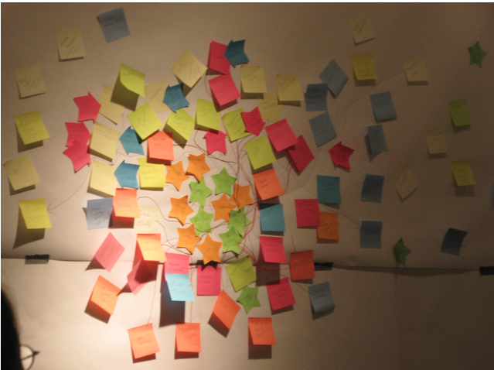

To locate people we hope to bring into the project as story-circle facilitators, trainers, story-catchers, and links out into the community, here’s a mapping exercise:

Jot down on sticky notes as many of your community’s formal organizations and informal groups (some examples listed at the end) as you can according to this plan:

Committee Members = Green star
Non-committee members= Yellow star
Formal and Informal Groups Likely to Participate: Hot Colors
Formal and Informal Groups Less Likely to Participate: Cool Colors
Crucial People to Get Involved (Hubs, Pulsetakers, Gatekeepers): Arrows

Add yourselves to the center circle.
Add groups most likely to participate in the next circle out.
Add groups perhaps likely to participate in the next circle, and so on.
Draw links between yourself and any group/individual to which you have a connection.
Arrange and cluster the groups according to location or group association or how you relate to them. Who is missing? Who do you know who might be connected to some of the outliers?

Once you take a good look at the map, how might you design a storytelling project that goes out to those who will be less likely to participate while you are gathering momentum with groups closer in? If you design small-group story circles for groups in the third circle out, you might pull some of these people in closer to the center.

Look for potential story-committee members from the groups in the second and third circle, especially people with a reach into areas more difficult to engage. See if they would like to be trained as story-circle facilitators, interviewers, story hosts.

Design a story project with awareness of the different circles, and the kinds of storytelling that might reach each.

FORMAL GROUPS
Employer
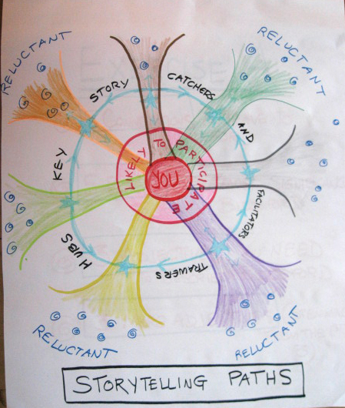
Business Associations
Nonprofit Groups
Cultural Organizations
Communications’ Organizations

Religious Organizations
Schools
Hospitals
Government: national, state, Local
City Services: Police, Fire
Libraries
Health Organizations
Charitable Groups
Arts Groups
Youth Groups (Scouts, etc)
Political Groups

SHADOW NETWORKS
Informal Groups form around:
Sports
Ethnic
Cultural
Neighborhood
Books & gardens & other interest-related
Pet-owners
Families with a parent at home
Collectors
Places people congregate

A Comparison: Interviews and Story Circles

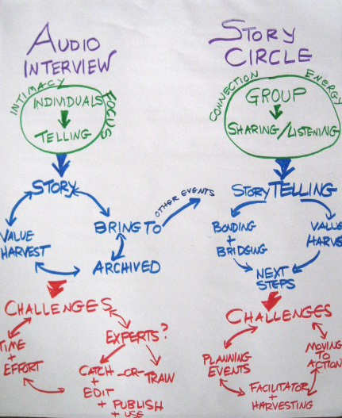

How Would Story Circles Help You Meet Your Goals? Work with Your Audience?

How Would Story Interviews Help You Meet Your Goals? Work with Your Audience?

Asking for Stories
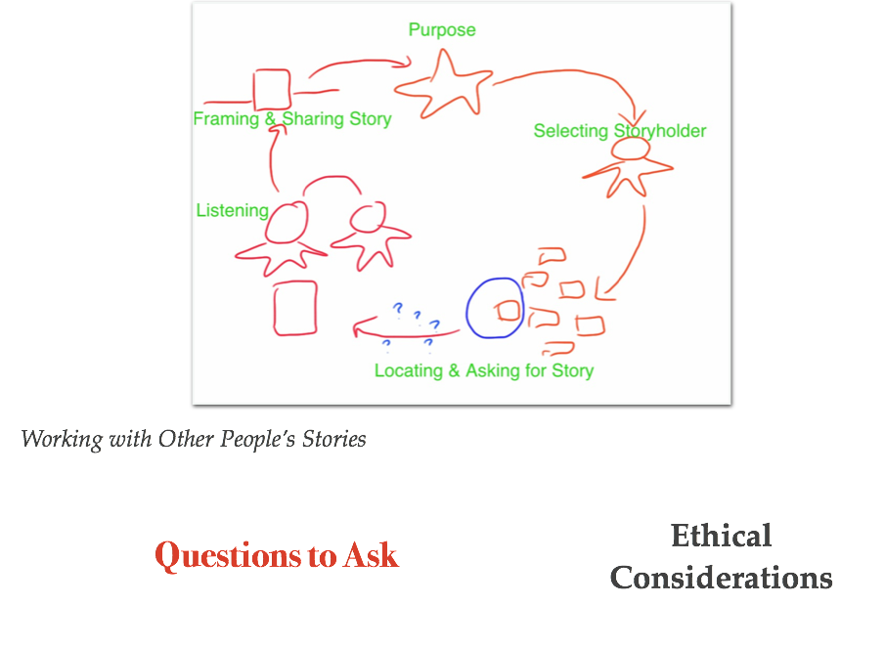
Questions to Help You Ask for a Story
- Tell me about a time when… (e.g. something/someone was helped; something happened to change things) What happened during that time…
- Tell me about your proudest moment in/with this organization. How did it happen?
- Tell us about an aha moment—when you understood what is possible in this work…
- Future Story: Tell me the story of my donation/grant, about how I will help...
- Challenge: What specific challenge did you face? What was challenging about it? What was at stake for you (and anyone else)?
- Choice: How did you engage with the challenge? What was the specific choice you made? Why did you make that choice? Did you receive help to meet the challenge? How did it feel in the moment?
- Outcome: What happened as a result of your choice? What change occurred? How did it feel? What hope can it give us? Why did it feel that way? What did it teach you? What do you want to teach us? How do you want us to feel?
A Sampling of Community Storytelling Activities and Events
to Encourage Engagement and to Mine Experience

I. Storytelling Exercises to build trust (bonds and bridges) while surfacing & sharing knowledge:

a. Story Plunge
Open a training/workshop/gathering/meeting with participants sharing stories of their experience with the topic (stories about what drew them to the community, or an experience with the heart of the community).

b. Visual Stories
Express experience through visuals:—we’re comfortable with the complexities of language, and so pulling away some of that language, or accompanying the language with a concrete, visual symbol can shake up our understanding, make things strange, give us new insight, open our eyes, help us to listen deeply.

Object Stories Participants bring an object that represents something they value about the community. In a circle, one by one, share the objects and related stories following the story-circle approach.

Map Stories Pin up a large map of the geographically-bounded community and give each person two sticky dots. Have them stick their dots on two places they consider “story hotspots”—places that hold important stories about the community, stories without which the full community story could not be told. Share these stories as described below. If you have a group at ease with storytelling and a skilled facilitator, you could ask people to place a Color A dot on a place they want to stay the same, and a Color B dot on a place they would like to change, Color C on a place they’d like to know more about.

Photo Stories Take photos of places that suggest the heart of the community; share the photos & their stories. Have the group add their own stories prompted by seeing the photos and hearing the stories. (This exercise is a good one for online groups as well, using a mapping tool.) You can also ask participants to take photos that suggest the NOW of the community and then photos that point to what they hope for the community in 20 years.

Postcard Stories
Blank postcards & bulletin boards for people to post stories/drawings about being proud of: Culture, Experience, Landscape, People
Or competitions for story postcards to be printed by community. (Can be done online)

c. Story Circles
Divide large gatherings into groups of six-eight people who do not know one another well. (You can also help this along by handing out numbers when people arrive)
Have small groups open with an overview of the purpose, the ground rules, and a brief introduction of each person “What brings you here tonight?”

Help the conversation take off by saying, “Think about…” and then asking a focused yet open question that invites a spectrum of emotion to make people feel welcome to talk about the things that are good about the town or need changing. Using the terms “experiences” and “examples” can sometimes produce better stories than the word “story” which can seem intimidating (“I’m not a storyteller!”) If your group wants more guidance, you can start off with your own story—your brief, yet detailed story in answer to the question.

One scenario that works well: first round—go around the circle, each person offers an example, an experience, an anecdote in response to the question. Go around the circle again, having people share insights gained from these stories. A third round could be more informal, a conversation including questions & responses. Another scenario allows for interruption by the facilitator if it seems as though additional detail would enhance the story. “Could you give an example?” “Could you tell us more about that?”

Make sure as a facilitator you do not punctuate the conversation with your own thoughts--you do not need to speak after each participant. This is crucial if you are to avoid dominating the conversation and turning it into an interview. You can write things down on a flip chart (or have someone else do this, or pass out sticky notes to everyone). SILENCE does not need to be filled. Give people room to think, to explore, to experience.

If someone in the group is a known talker and might well dominate or even interrupt others, sit next to that person. Not being able to have eye contact with the facilitator can reduce the urge to speak.

If someone goes way off topic, do not interrupt. When there’s an opening, ask the person to relate the story or statement to the topic. If someone starts to spout positions rather than interests, or get rather heated, inject light humor or gently ask the person a question to move things to a positive place. “Tell us more about….”

Use sticky notes to jot down keywords about what people heard (one sticky note per value/keyword/theme/topic). Make sure you emphasize the positive—what did we hear that we want to keep? That we want to work towards?

Have everyone post their sticky notes to a flipchart sheet and then cluster them by theme. Group similar or related themes to locate potential common ground and discrepancies within a group’s stories, to provide a springboard to discussion that can specify as precisely as possible what is meant by one of the more general terms people often use. For example, many groups come up with “friendliness” or “natural beauty” as qualities they value in their communities. We’re trying to get them to say more, which we do by drilling down into that word, by looking at the word next to similar words, and in relation to other values. Looking at the themes as a group can reveal conflicts as well as common ground, providing an authentic, detailed picture of the community. They can, if they wish, prioritize the themes as well and discuss qualities of the community that did not come out of these stories but that are important to them.

Draw out more detail by drawing rays/arms/branches to link ideas and to add more specificity. Discuss the results.

II. Micro-exercises
Short short exercises (10 minutes tops) to shake up the thinking:

Name Tags To pull away the buffer of language’s padding & point directly to what matters, write your name in the center of the name tag. In the spaces around your name write five words that suggest what you value about this topic, or five places where you see this topic at work, or…

Metaphors Pass out photos (landscapes, macro-shots, people shots—it almost doesn’t matter what images you choose), one to a person. Each person writes down a metaphor suggested by that image for the topic at hand: e.g. a quality of the community or a challenge within the community. Pass the photo and metaphor one person to the right; that person extends or deepens or responds to the original metaphor. In pairs discuss the results.

Draw the Map Hand out several crayons per person (or put a large assortment of crayons in the center of the table) and ask participants to draw the map of their community. Share and compare.

Draw the Community Hand out crayons and paper. Ask everyone to draw the community through color, symbol, abstraction. Share and compare, even assemble a larger community portrait from the individual versions.

Collaborative Drawing (A Listening Exercise): One piece of paper, one marker, two people, no talking. When facilitator gives the prompt, Person A starts drawing a face. When the facilitator says “B,” Person A hands the marker to person B who continues the drawing. The facilitator goes back and forth, giving short, uneven intervals for each to draw, ending with instructions to finish the face. Then Person B writes down the first letter of the person’s name, switch to person A, B, A, etc. until the name is complete. The most important thing is to make sure there is absolutely no talking during the exercise. Follow with the pairs sharing their drawings and discussing as a large group what was revealed about leading/following/directing/listening.

III. Locative Stories Embedded into the Landscape

- 100 People/One Question Interviews. See http://fiftypeopleonequestion.com/
- Murmur-type project (http://murmurtoronto.ca/index.php) or online version. People add their place-based stories via mobile devices or visually.
- Story Quilt/Story Murals (drawn, painted, photographed & projected a la JR)
- http://jr-art.net/ Also can be done online with collage/poster software
- Story Benches/Story Boxes/ Story Circles/Story Art Set into the Landscape
- 100 Journals Project Blank journals placed about the community (especially in Third Places): http://www.1000journals.com/

IV. Community Storytelling Events

- Storytelling Activities Integrated into Existing Community Events with storytelling games and storytelling booths (audio and audio/visual).
- The Moth-type Storytelling gatherings (recorded): http://themoth.org/
- The Sounds of the Community Story Collage
- Invite people to bring in a brief recording of the sounds of the place and people (ambient/voice/music).
- StoryCorps-type Interview Project See http://storycorps.org/
- Day in the Life of…Project See http://www.olympus-global.com/en/event/DITLA/
- Digital Stories See Center for Digital Storytelling: http://storycenter.org and Capture Wales
- Printed Story Collections & Newsletters

V. Dialogue/Conversation

Community Café (adapted from World Café and Talking Circles)
A community café is an opportunity for informal yet spirited discussion on topics that matter to the community. A café can be hosted regularly in Third Places or rotated around the community; it can lead to the formation of action groups, to further study, to planning events and activities or it can be a way just to bring the community together. Make sure you choose an inviting, welcoming location; clearly set the intention for the gathering; ask powerful questions; trust emergence and harvest the learning.

The full group sets the ground rules for the café. Here are some guidelines: Set the time limit for each round (20 mins or so); each person speaks for a maximum of two minutes, following by the next person in the circle and so on until everyone has a chance to speak on the topic. Once everyone gets a first say, open up the conversation, making sure everyone feels invited into the circle. Respectful speaking and listening including making eye contact; cellphones off; staying on topic; everyone has the right to pass their turn.

Round One: In groups of 4-5, sit in a circle (a small café table is fine but not necessary). One person volunteers to be the note-taker and “host” (to stay behind during Round 2).
Round Two: Everyone but the host switches tables, being sure not to go as a group to the next table. The host at the new table summarizes the conversation that occurred there. The new group has an opportunity to speak to that summary then tackles the next question posed, following the same rules.
Round Three: People go to new tables; host stays behind to summarize and take notes. Each person has a chance to engage with the summary and then the round takes on the final question(s).

Conclusion: The hosts report to the full group—those notes are collected. The full group can at this point move into a facilitated discussion of next steps, or clustering and sorting the themes that have surfaced and planning next gathering, action groups, etc.

Building a Community Storytelling Strategy
Why Do You Need a Storytelling Strategy?

What Is Your Story Timeline

Stock a Story Bank

Become a Storytelling Organization
Sharpen Storytelling & Gathering Skills
Add Media Capacity as Needed
Share & Gather Internal Stories
Host Story Events & Projects

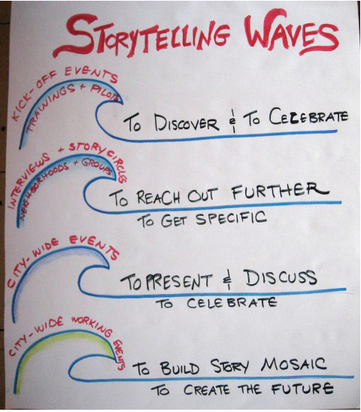

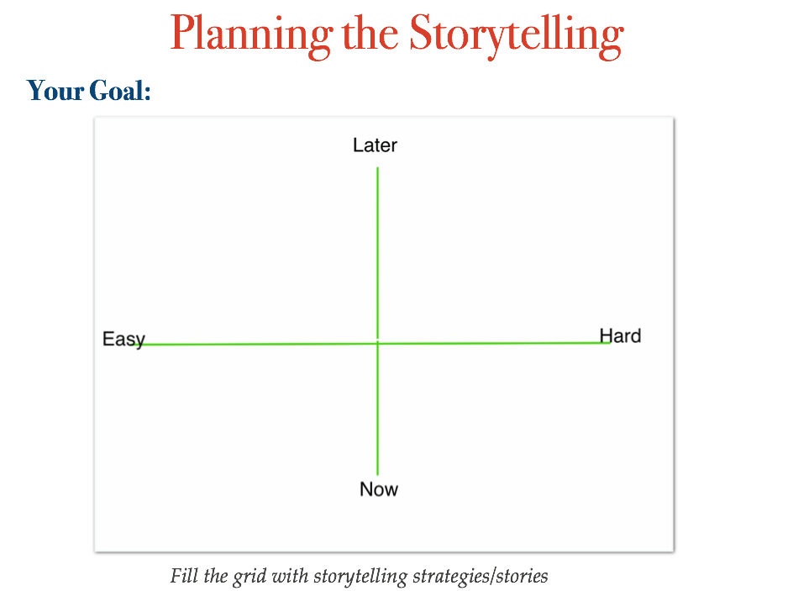

RESOURCES

Slide Deck from the Workshop

Storytelling Resources List
http://community-expressions.com/2014-workshop-storytelling-to-build-community/
http://community-expressions.com/resources-3/2014-vcf-and-bjf-art-of-storytelling-workshop/
(I have compiled several lists for you here.)

Questions? Contact Barbara Ganley
Phone: 802 989 1885 Email: barbaraganley@gmail.com

