
COMMUNITY EXPRESSIONS, LLC
Bringing Story to the Heart of Communities

The Art of Storytelling VCF & BJF 2014 Workshop
With Barbara Ganley

“We are, as a species, addicted to story. Even when the body goes to sleep, the mind stays up all night, telling itself stories.” Jonathan Gottschall
Facts add substance to stories; stories give meaning to facts. –Lee Lefevre

HOUR ONE The Story, The Telling

- Opening Storytelling Exercise: Story Circles

- What Makes a Good Story and a Good Telling

- The What & Why of Story and the Story Moment

HOUR TWO Mine, Yours, Ours: The Many Ways of the NonProfit Story

- The Nonprofit Story: Purpose and Audience

- Finding the Right Story(ies)

15-Minute Break

HOUR THREE The Nonprofit Story: From Oral to Visual

- The Visual Story: Text and Image, Short and Long

- Planning a Visual Story

HOUR FOUR The Long View: Planning A Storytelling Strategy & Sharing

A. Approaches to a Storytelling Strategy--Media, Channels, Choices

B. Performance: Stories & Strategies from the Day

C. Conclusion: Story of Today and Glimpses Ahead

What do we mean by story?

Freytag’s Pyramid

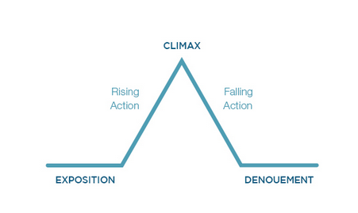
Sequence: Hero—Something’s at Stake--Challenge--Something Happens—Change

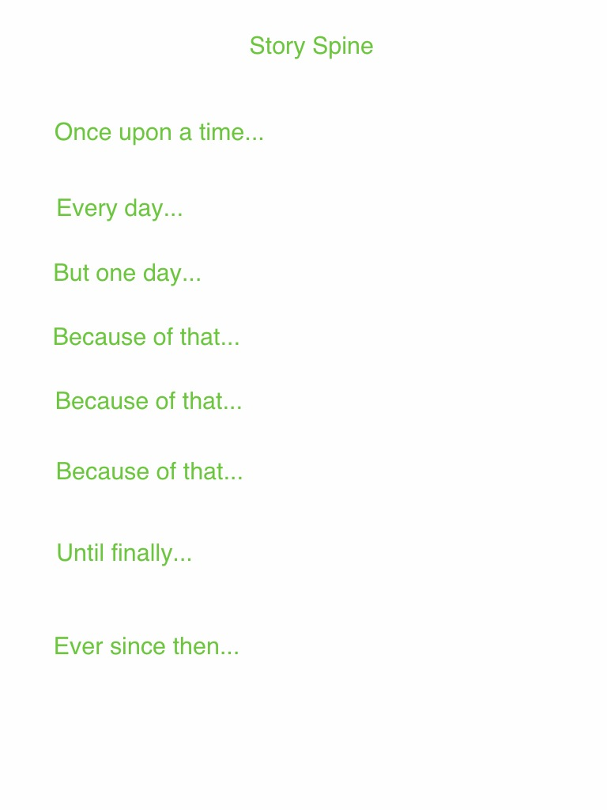
Kenn Adams

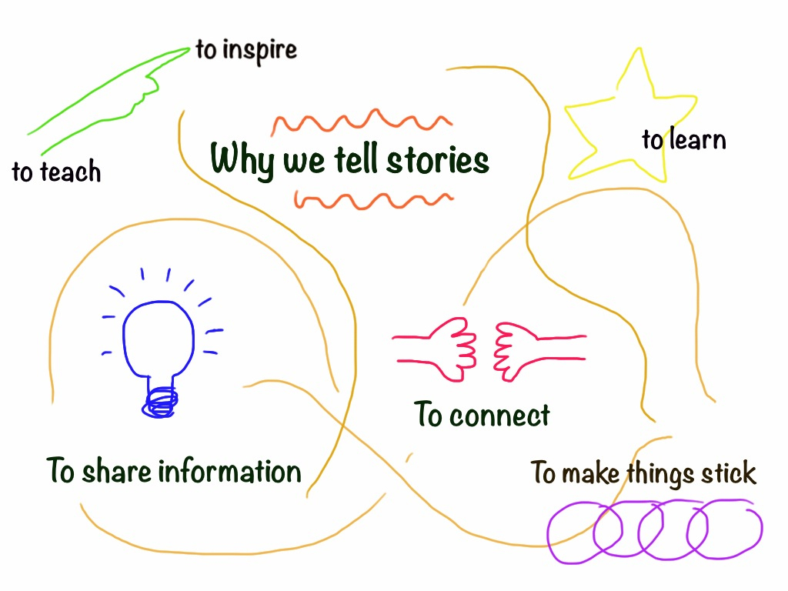

What makes a great story?

What makes a great storytelling?

How Stories Work: The Story Relationship
“It takes two to story.” Richard Kearney

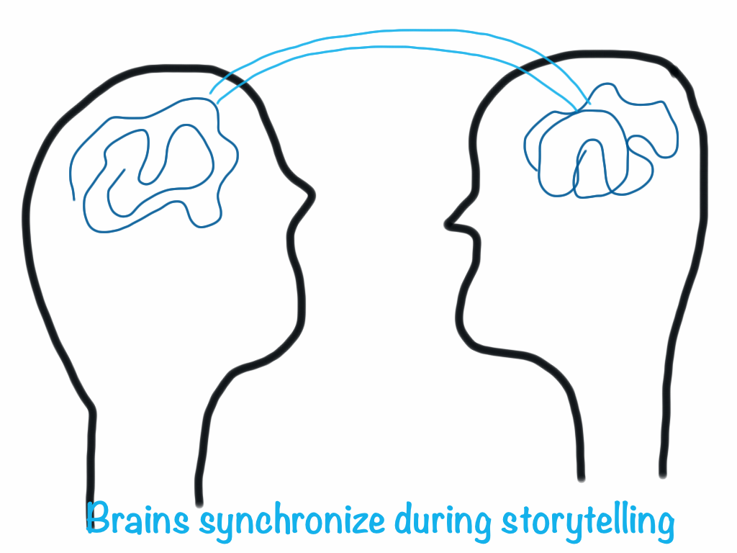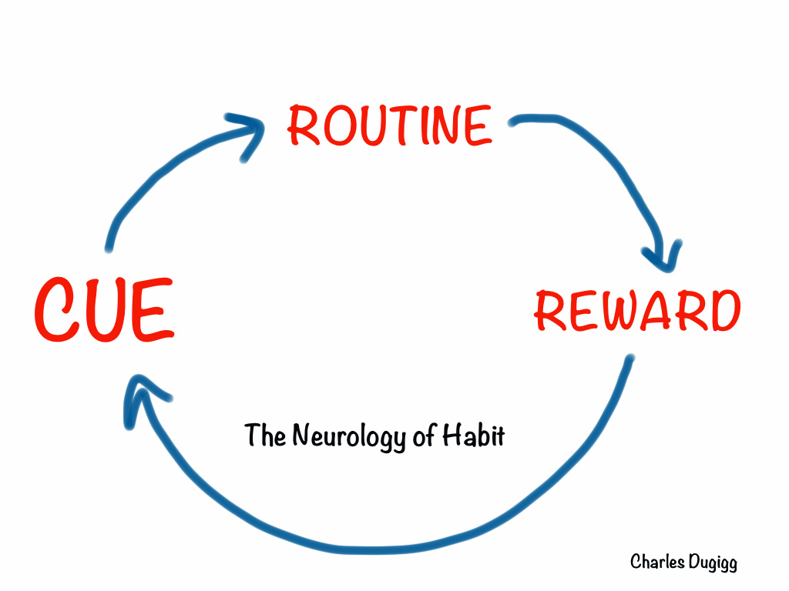

The story keeps the AUDIENCE in the center of things—the story must be CREDIBLE, RELEVANT, COMPELLING. How are you appealing to the mind, the heart and hand?

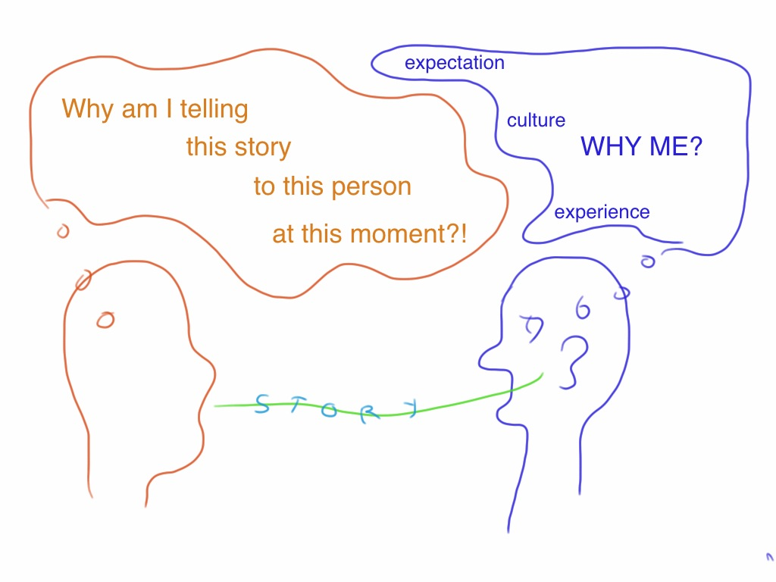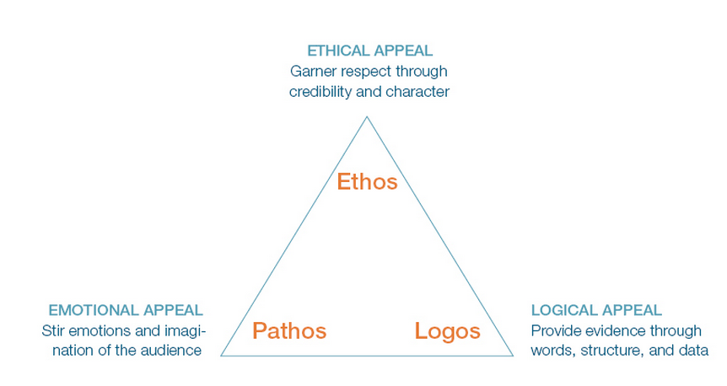

(Image http://www.duarte.com/book/resonate/)

RELEVANCE Does the mission intersect with my interests, experience and expertise?

APPEAL How does this satisfy my need for facts? How does it touch my heart?

ROLE Donation, participation, information, connection?

FUTURE (Why should I return?) Will they evaluate the work? Will they keep me informed of developments and outcomes?

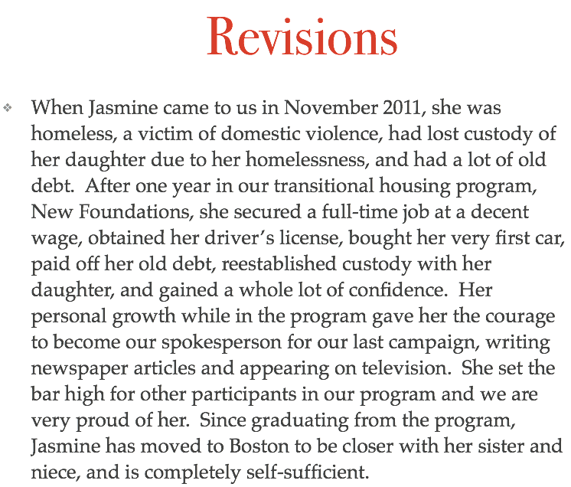

Turn this draft into as effective a nonprofit story as you can, keeping in mind the following:
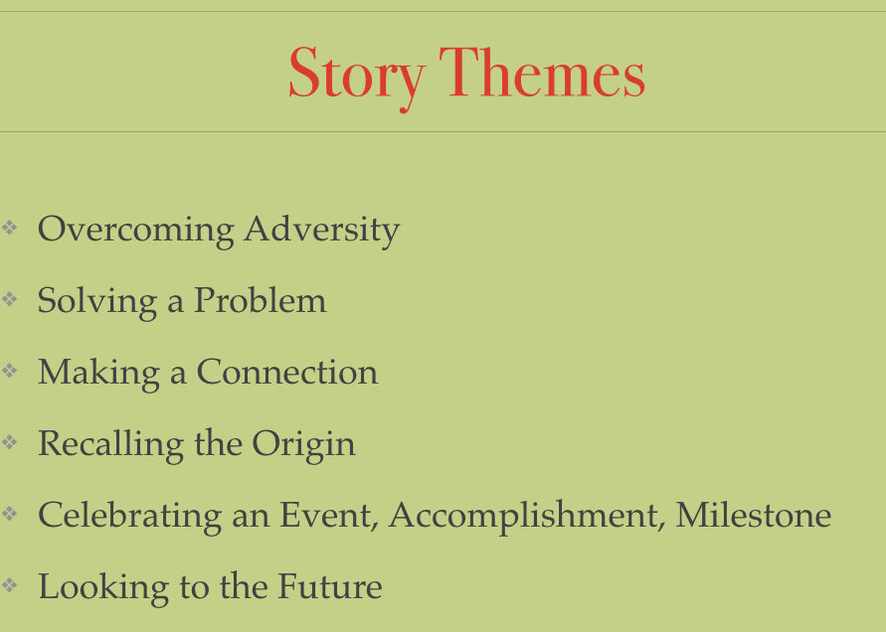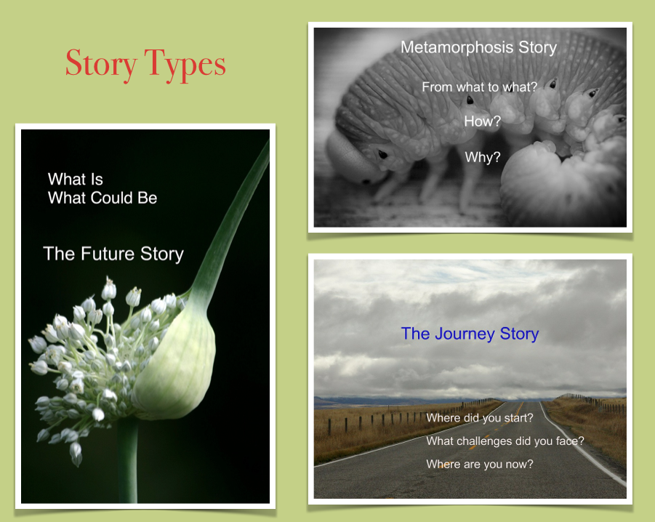

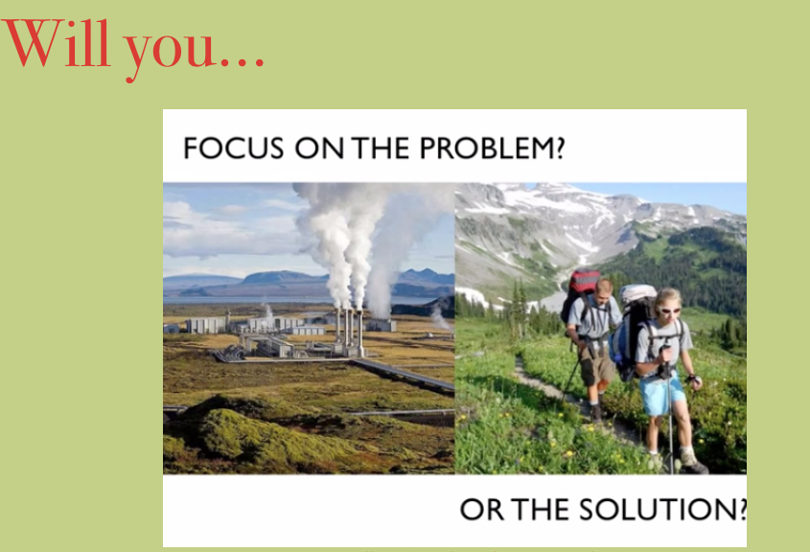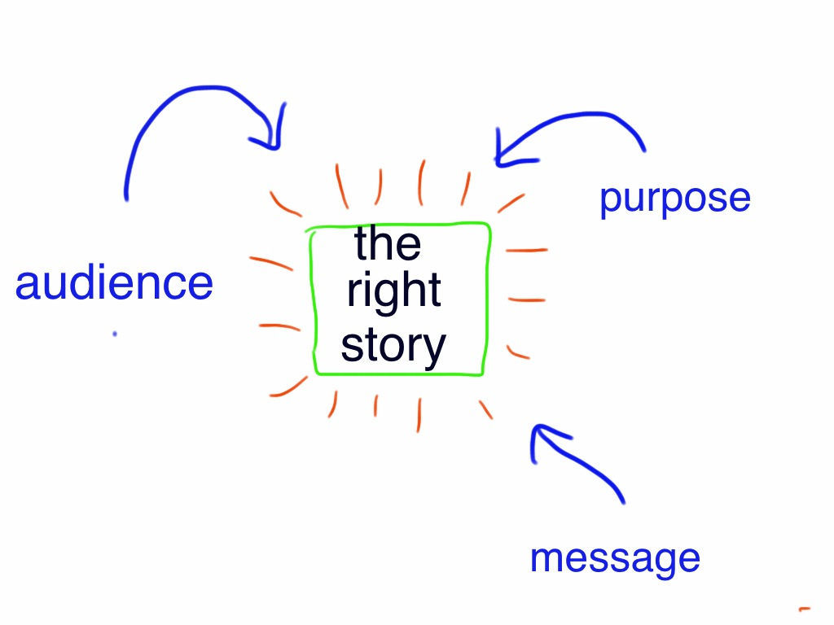

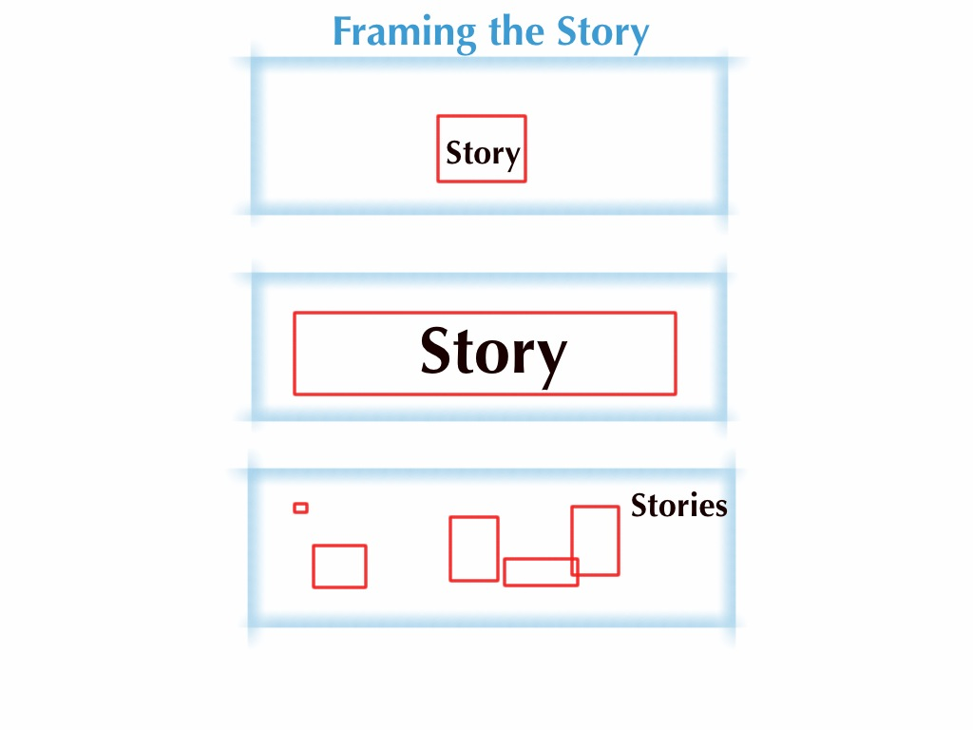

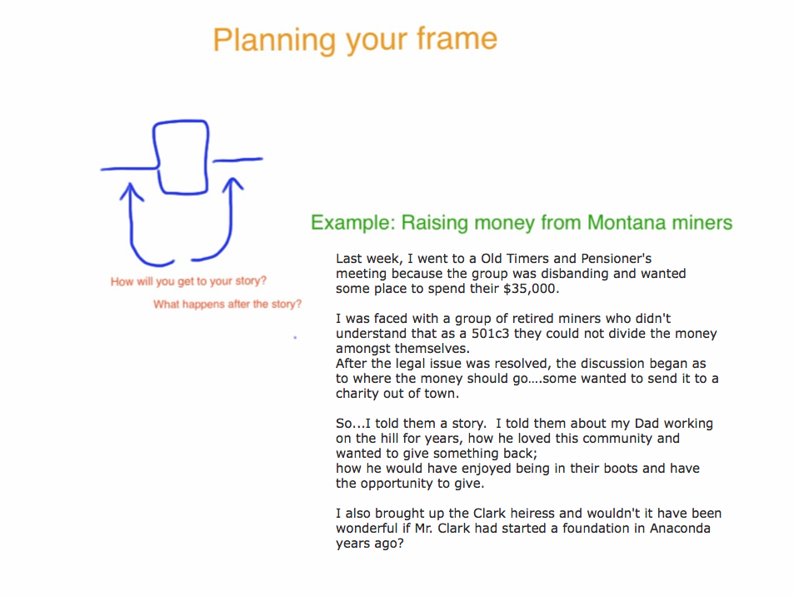

Questions to Ask Your Nonprofit Story

1. Do you know your audience, your purpose, your message? Are they aligned? Are they clear in the story?

2. Which channels are most effective for this story and audience?

3. What media will you use? Are you thinking of your audience?

4. Do you have the know-how and the capacity to bring this story to life? If you don’t, who could help you?

5. What theme does your story follow?
Overcoming Adversity
Solving a Problem
Making a Connection
Recalling the Origin
Celebrating an Event, Accomplishment, Milestone
Looking to the Future
Failing

6. Have you framed the story well – what comes before and after the story?

7. Are you emphasizing the problem or the solution?

8. Who gets to tell this story? Why?

9. Who is the hero? Is your hero memorable? Will your audience care about him/her?

10. Does the story open at the last possible moment? Have a compelling ending?

11. What is at stake in the story? Where is the tension?

12. Where is the shift, the change? Is it implied?

13. Is the story as short and simple as it could be (without loss)?

14. Is the message clear?

15. Is the language lively and appealing and jargon-free?

16. Is the story free of clichés?

17. If this story will appear on the Web, are you using the visual elements to full advantage? Does text + image = more than the sum of their parts? Is video serving your story?

Finding the Right Story

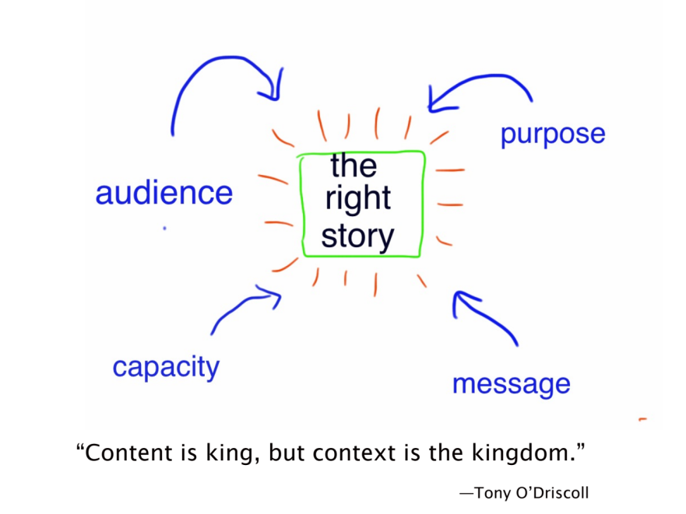

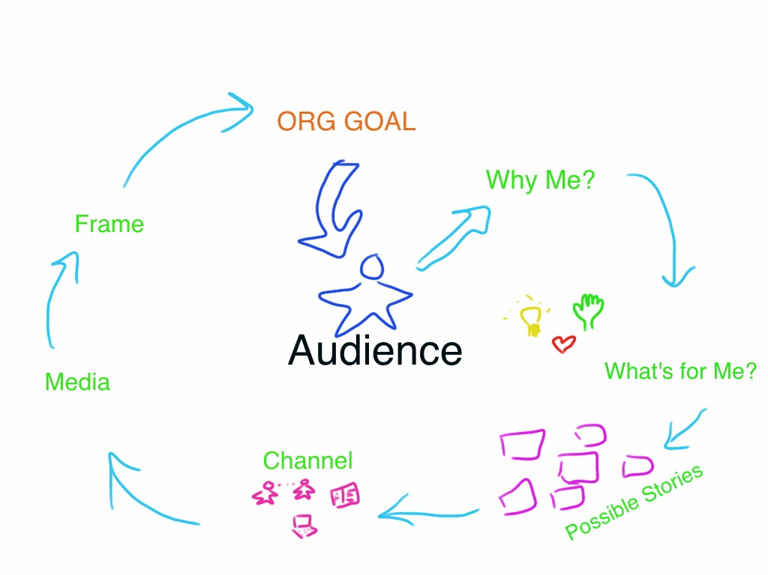

Exercise: Finding the Right Stories (and Overlooked Gems) in your Mission or Project Goals

Set-up: A Flipchart sheet, four pack of sticky notes of four colors, pens

1. List 6 adjectives, 6 verbs and 6 nouns that help you describe your mission/project goals (no jargon)

*Tip—If your initial list includes general verbs, for instance, such as “help,” try to generate a list of six more verbs (or adjectives/nouns) from the general, umbrella ones.
*Tip—This exercise is particularly effective done in a group, so that word choices/stories/story holders/ audience can be compared and discussed to gain insights into your project, your range of viewpoints, and stories.
*Tip---Do this exercise on a large flipchart sheet, whiteboard, or papered wall; keep it for a few days/weeks and invite people add to it, including sticky notes with ideas as to how to gather and use these stories.

2. After discussing the words you have come up with (if you’re working in a group), start a brainstorm session with sticky notes (one color only): write down as many stories you know of or you’d like to find (either true or scenario stories) beneath each word.

Keep going for ten minutes or more, as quickly as you can. Do not eliminate anything at this point. Let stories beget stories.

If some verbs/adjs/nouns fail to generate stories or story ides, discuss what that could indicate about that word and the organization/project.

Stick the stories on the sheet beneath their verbs/adjectives/nouns.

3. On second-color sticky notes, jot down potential story holders/tellers for each story/one holder per note.

Stick them beneath their stories.

4. On third-color sticky notes, jot down potential audiences for each. word/story/holder. One audience to one note. Stick them beneath the story holders.

5. Step back and take note of where you have a wealth of stories and where you are lacking them. What messages do you wish to convey? Which stories will best meet your needs? Which stories will be easy to gather and use? Which stories hard? Who might help you?

6. Make a plan of next steps.

Creating a Story Bank:

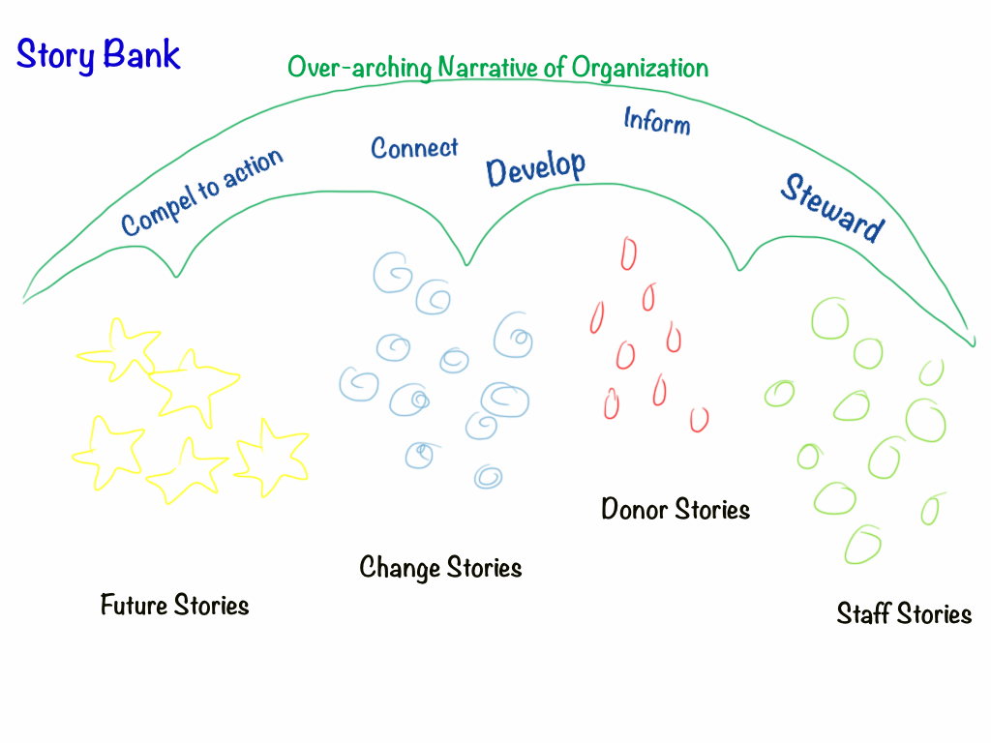

How are you organizing your stories?

Have you developed a system of tagging them for easy retrieval, comparison, and evaluation? (A powerful exercise to do as a staff: come up with the categories and tags together as you sort through the stories—you will learn more about each other and the work you do as you look at your project from different perspectives.)

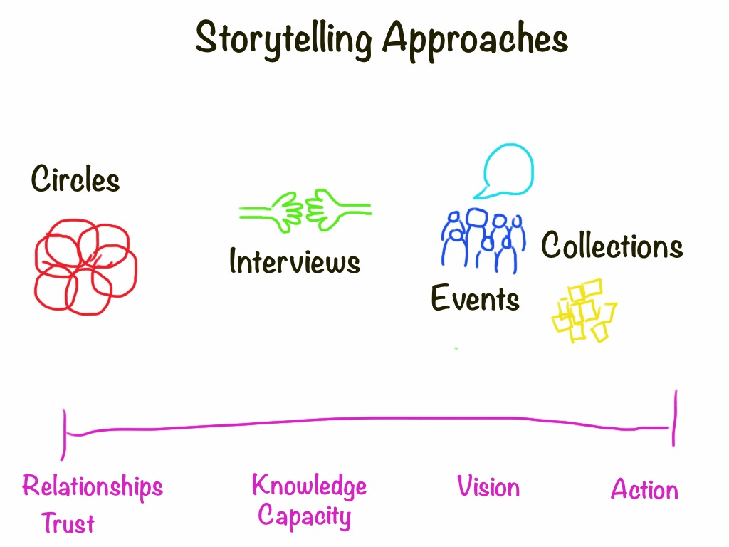

STORY CHANNELS

ONE-ON-ONE CONVERSATION
ORAL PRESENTATION/PITCH
NEWSLETTER/EMAIL
ANNUAL REPORT
GRANT APPLICATION
PRESS RELEASE
WEBSITE
SOCIAL MEDIA
FUNDRAISING APPEAL LETTER
POSTER
RADIO SPOT
TELEVISION INTERVIEW
ADVERTISEMENT

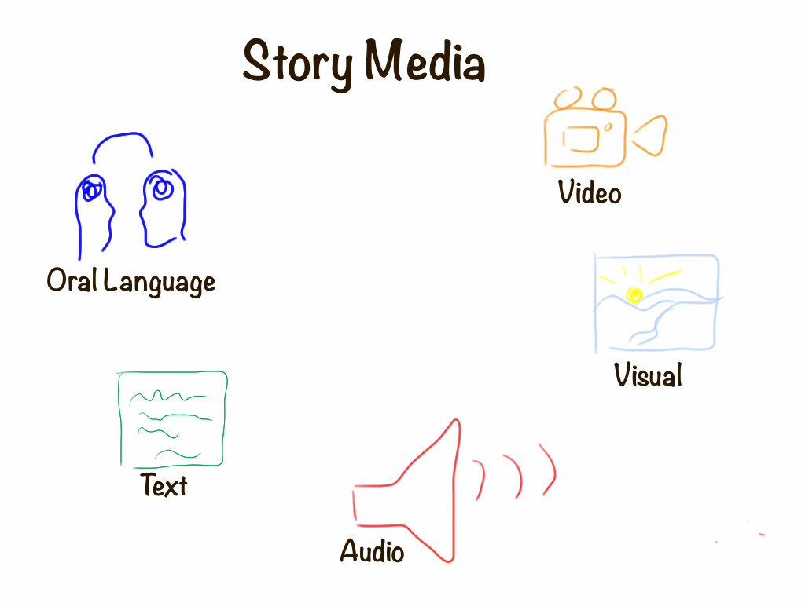

Gathering Stories
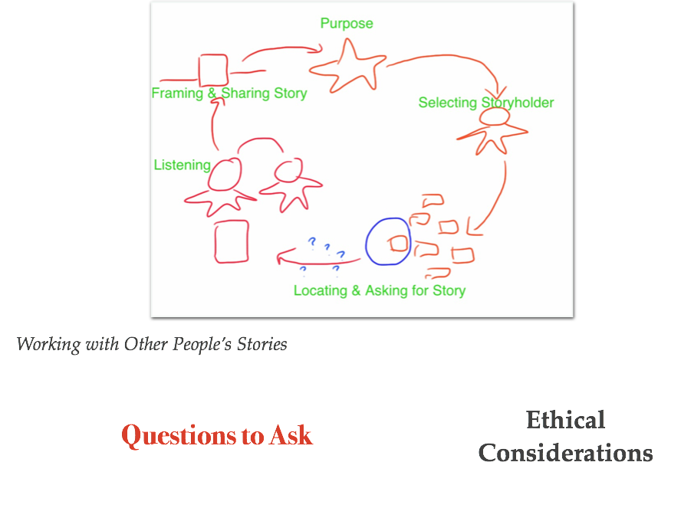
Questions to Help You Ask for a Story
- Tell me about a time when… (e.g. something/someone was helped; something happened to change things) What happened during that time…
- Tell me about your proudest moment in/with this organization. How did it happen?
- Tell us about an aha moment—when you understood what is possible in this work…
- Future Story: Tell me the story of my donation/grant, about how I will help...
- Challenge: What specific challenge did you face? What was challenging about it? What was at stake for you (and anyone else)?
- Choice: How did you engage with the challenge? What was the specific choice you made? Why did you make that choice? Did you receive help to meet the challenge? How did it feel in the moment?
- Outcome: What happened as a result of your choice? What change occurred? How did it feel? What hope can it give us? Why did it feel that way? What did it teach you? What do you want to teach us? How do you want us to feel?
Building a Storytelling Strategy
Why Do You Need a Storytelling Strategy?

What Is Your Story Timeline
Stories You Need Now, Soon, Later

Stock a Story Bank
Donor, Staff & Client Stories … Past, Present & Future Stories
Scenario Stories…Nutshell & Full Stories

Become a Storytelling Organization
Sharpen Storytelling & Gathering Skills
Add Media Capacity as Needed
Share & Gather Internal Stories
Host Story Events & Projects

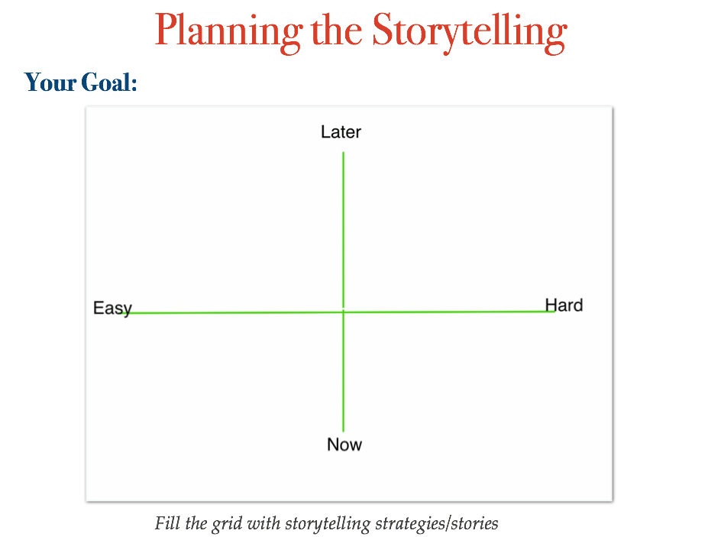

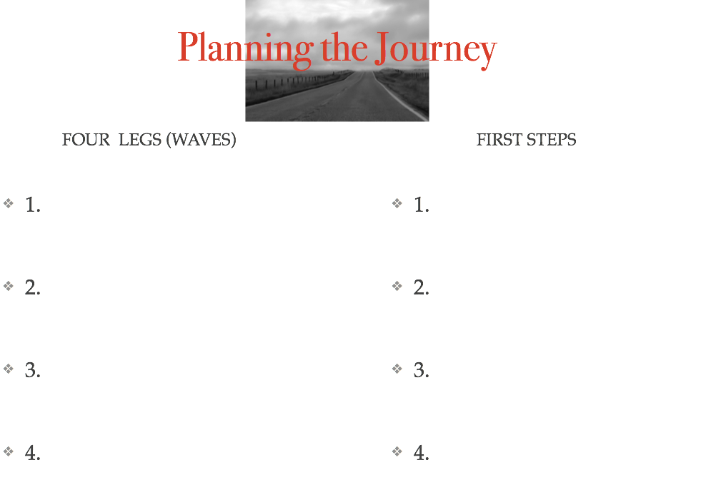

Media Choices

See Barbara Ganley’s Scoop-it page for updated resources: http://www.scoop.it/t/nonprofit-storytelling-by-barbara-ganley

Why Use Written Stories?
*Easy to gather — people can do them on their own
*Accessible to many—Letters-to-self-to-town-to-world can deepen bonds with community
*Easy to extract meaning and information *Honors traditions of stories

Publishing and Sharing
Newsletters
Local newspapers
Website/blog/email/social media
Community displays: bulletin boards, etc.
Contests: Calendar stories, essays, postcards
Self-published books
Public readings
Letters to the Town Stories

Why Use Audio Stories?
*The equipment is relatively inexpensive and easy to use.
*A microphone is less intrusive than a video camera. People can be more natural – more themselves in the company of a good interviewer or group.
*Audio forces the teller/catcher to be creative & pay attention to words, sound & language.
*Audio is intimate. When you hear someone’s voice on a podcast, it seems as if they’re talking directly to you. Swedish researchers have found that audio creates more of a sense of co-presence than does text.
*In a one-on-one interview, the sharer is heard directly and feel valued; the listener gains insight and connects to the sharer in a new way.

Publishing and Sharing
Conversation cafe/Story circles
Storybooths a la StoryCorps: CD
Interviews
Podcasts
Story Tours: Example from The Murmur Project or Artmobs
Website, Blogs
Radio: Example from Rural Voices Radio

VISUAL STORIES
Why Choose Visual Stories
*Single Images (Still photos, paintings, etc) convey strong emotion, a single point or mood
*They can speak more loudly than words, especially in this image-centered era
*Images can show things differently, and show different things.
*Easy to place in the landscape for an ongoing presence
*Terrific way to engage people in a collaborative project (see mnural project examples)

Digital Tools
Soundslide
Alan Levine's List of Storytelling Tools

Publishing and Sharing
Calendars
Artshows (Visions of the Now and of the Future) Example of an Online Exhibition
Photo-stories pinned to map/bulletin board or online (Pinterest, etc)
Postcards
Slide-stories
Before-and-After Photo Displays
Posters or Murals Example from Canada, another from Moose Jaw, Saskatchewan, one fromPhiladephia, one from Duke University's Face Up! Project, from high school students in Denver--a mural club, a series from Chemainus, British Columbia

Multimedia

Why Choose Multimedia
*Video brings viewers to the action, to the place central to see and hear.
*Mixing text and image well can amplify the message: two plus two equals far more than four.
*Audio and image complement one another, bringing the viewer close to the teller and to the teller's perspective.
*Great way to engage youth

Tools
Video Editing: Basic tools-- iMovie (Mac) and Moviemaker (PC) ; Advanced tools: Premiere (PC), FinalCutPro (Mac)
Webvideo Free, online and excellent!
Vine & Instagram
Voicethread for voice/image/text;
Compendium of free, easy-to-use digital tools, described here by Alan Levine
Soundslide example (Many newspapers use this professional quality tool--inexpensive)

HOW-TOs:
See Community Expressions’ list of resources: http://community-expressions.com/digital-storytelling-for-nonprofits/ (Scroll down to tools section)
Storyboarding: Excellent Guide to planning your story http://multimedia.journalism.berkeley.edu/tutorials/starttofinish/storyboarding/
Micro-videos (Vine & Instagram) guide and examples: http://www.slideshare.net/AaronMSB/teeny-tiny-video-great-big-impact

RESOURCES

Slide Deck from the Workshop
http://communityexpressions.files.wordpress.com/2014/03/april-the-art-of-storytelling-workshop.pdf

Storytelling Resources List
http://community-expressions.com/resources-3/2014-vcf-and-bjf-art-of-storytelling-workshop/ (I have compiled several lists for you here.)

Questions? Contact Barbara Ganley
Phone: 802 989 1885 Email: barbaraganley@gmail.com

