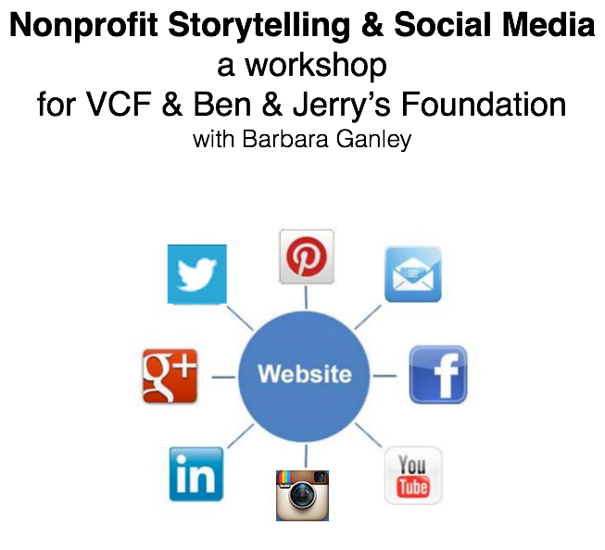

Hour One
A Look at the Storytelling & Social Media Landscape

Hour Two
Blogs & Facebook

Hour Three
Twitter & Visual Sites

Hour Four
Your Social Media Strategy

Workshop Slides and Resources: http://community-expressions.com/resources-3/social-media-storytelling/

Blogging Exercise

1. Draft a blog version of your story on a large sticky note (100 – 200 words). Make it legible! Include notes/drawings about images to include.

2. Place all group blogposts on a large flipchart sheet.

3. Read the other posts from your group and choose between the following for each. You must write at least one comment (b) and one blog post (c) in total.

a. Give it a LOVE
b. Write a comment (on small sticky note; attach to original post)
c. Write that you’ll create your own blogpost in response (on small sticky note)—give your promised blogpost a title.
d. Nothing at all

4. Read comments and posts written in response to your original and write a response or not (choose to carry on the conversation or not).

Notes & Ideas



Facebook Storytelling Exercise

1. On a medium-sized sticky note, draft a Facebook version of your story (100 words max). Include at least one hashtag. Add images (or notes about images) if you like.

2. In your small groups, give each other feedback:

• Would you be inclined to read the entire post and return or click links?
• Would you want to leave a comment? Like the post?
• Do the images draw you in? The text?
• Suggestions?

Notes & Ideas

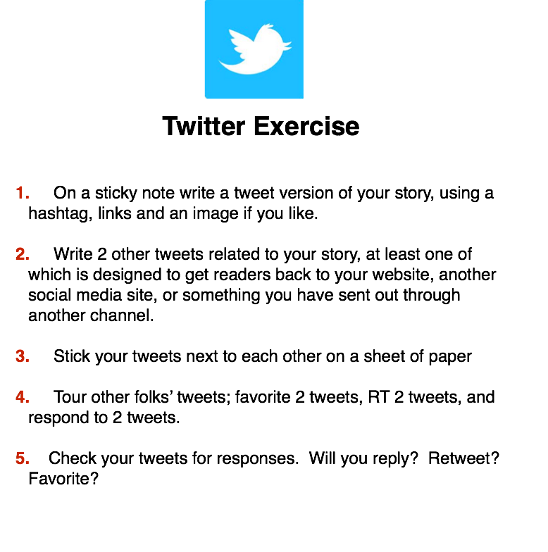
Notes & Ideas:

Planning Visual Storytelling on Social Media

Do you have a visual story bank filled with a range of storytelling images?

What sorts of images do you have? What do you need? Where might you get or take these images?

How might social media storytelling help you to grow your practice as a visual storytelling organization?

Why is it important for you to become a visual storytelling organization?

How will you explain visual storytelling & social media to your co-workers tomorrow?

What does being an ethical visual storytelling organization mean to you?

Will you use Pinterest or Instagram or Flickr in addition to Facebook, Twitter & your Website/blogging? Why or why not?

BUILDING YOUR SOCIAL MEDIA STORYTELLING STRATEGY

** Why are you using social media storytelling? How does it serve your mission (the bigger story)? Ask “What for” then “What”

** Who is your target audience(s)? Where are they?

** How are you weaving the bigger story by choosing channels
to match stories & linking between versions and back to your website?

** What will success look like? Next month? Next year?

** A Question of Capacity: Do you have the skills & the time & staff to accomplish your social media goals? Who will do what? How is your entire organization tied to the strategy, the outcomes and processes?

** What unique story do you have to tell and value to offer? How are you engaged in listening? (How are you using the social in social media?)

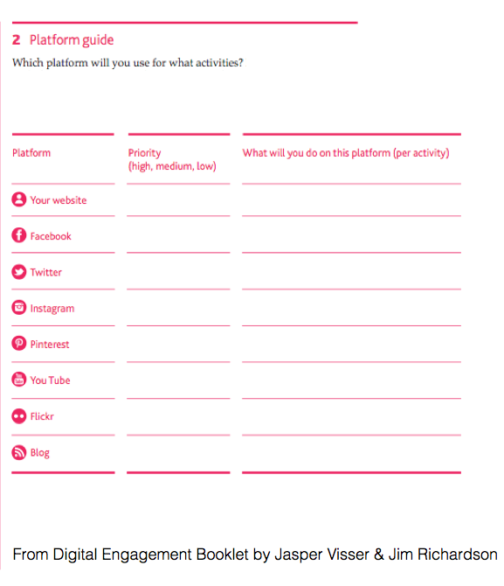

FOUR STEPS YOU WILL TAKE
RIGHT AWAY

1.

2.

3.

4.

