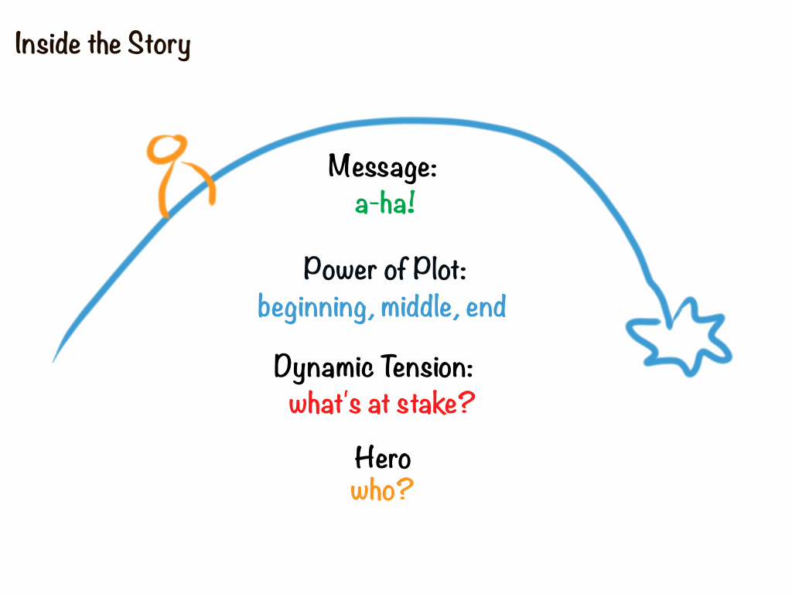

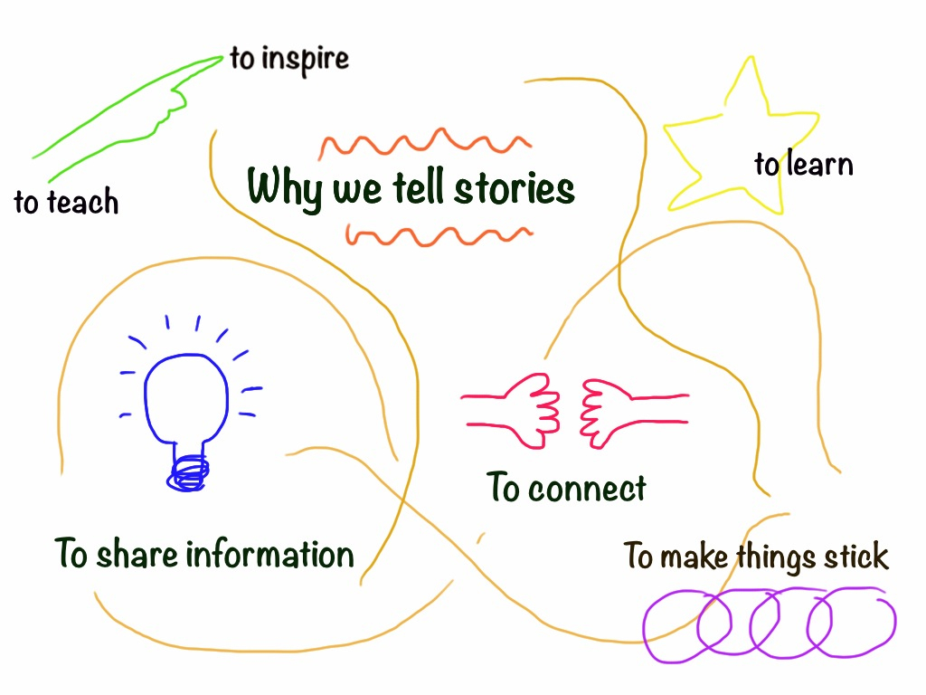

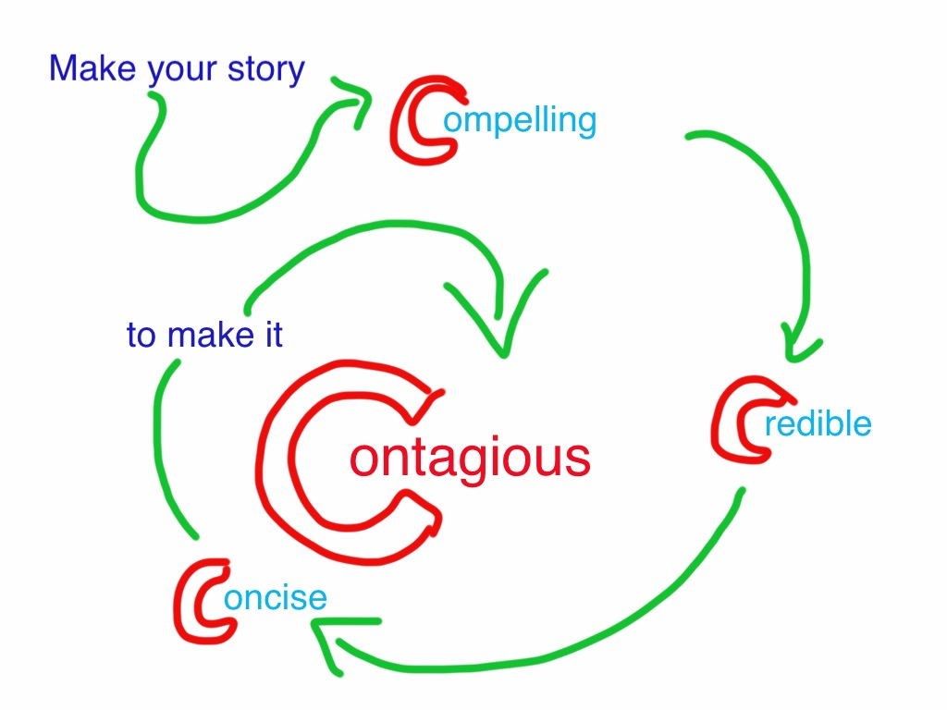

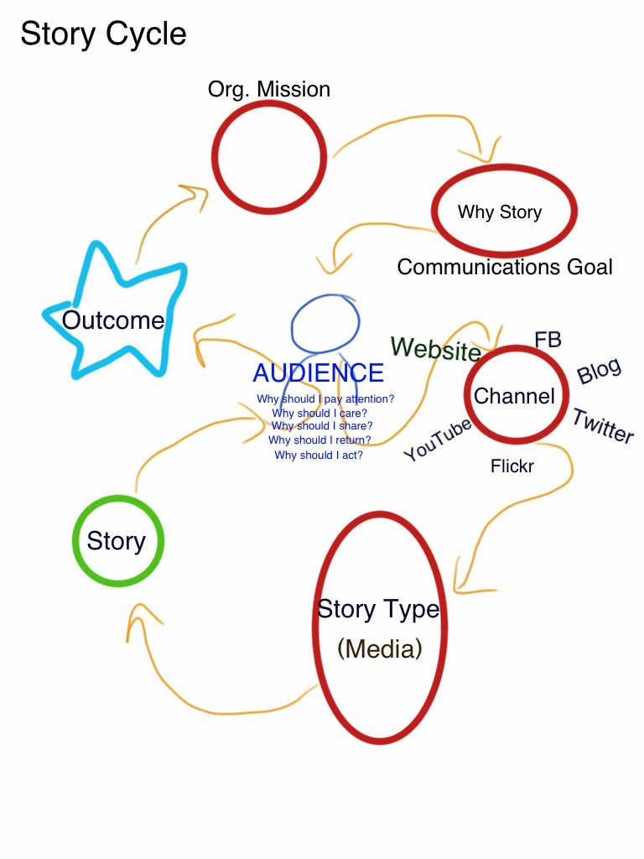

How To Use Pixlr

- Open pixlr.com and choose Pixlr express (Efficient)

- Upload a picture from your desktop or a specific photo URL.

- To edit the image, click on Adjustment 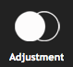. Some of our favorite tools are: Color Splash (to make black & white, or add just splashes of color); Color ; Vibrance 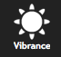; Contrast 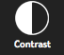; and Focal blur . Make sure you click Apply when you’re ready to save your changes. You can always click Undo if you change your mind.

- You can also play around with Effect 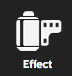, Overlay 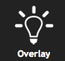, and Border 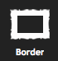
- just remember often less is more!

- Add text . First choose the style then type your text into the box. Then work on the font, color, size and placement.

- Remember to save at the end! Name your file and choose the highest quality (you can always resize later). Then choose where on your computer to save the file.

How to use Soundslides Plus v1.9.5

- If you don’t already have Soundslides on your computer go to soundslides.com and download the free trial of Soundslides Plus v1.9.5. Install the program on your computer.

- Make sure you have your photos (.JPG format) and audio (.MP3 format) already chosen and edited in one folder on your computer.

- Open Soundslides. Enter your email address and click Later if you’re using the demo. Click on the JPG button and select the entire folder where you have stored your selected photos. Then click on the SND and select the audio file.

- Edit your slideshow. Rearrange the images and then adjust the timing for each image by dragging the ends in the timeline at the bottom.

- To edit the type and duration of transitions between photos, click on the dash button at the bottom of the timeline.

- Click on Project Info at the top to add a Headline. If you don’t want the Headline, Captions or Credits to show while playing, go to Template at the top and unclick these options. You can also change background color options.

- To add text, click on Audio at the top and then Lower Thirds. Add a name, title and then adjust the placement and duration.

- Make sure you save each time you edit. Click Test to preview slideshow.

- Export when you’ve finished. It will create a folder called publish_to_web inside the project folder. The entire contents of this folder must be uploaded to your website for the slideshow to work properly.

- The easiest way to put your slideshow online:
- Click on File > Export and Zip
- Upload to Soundslides Video Converter: http://tools.soundslides.com/converter/
- Post to YouTube, blog or burn to a disc.

*Note: If using a demo version, it will not allow you to convert the video to put on your website. For this option, you will need to buy the program.

Here is a link to the full manual: http://support.soundslides.com/index.php?pg=kb.book&id=2

How to Use Audacity 2.0.3

- If you don’t already have Audacity on your computer, go to audacity.sourceforge.net/download/ and download for Windows or Mac and then install the program.
- Open Audacity and select File > New. Give your new project a name and save it as a .AUP file (we will export the file at the end so it can be read by other programs)
- Click on File > Import > Audio and select the first audio file you want to work with.
- To listen to the entire file, click the Play button. *TIP: Make sure you click Stop  NOT Pause  while in editing.
- Use the Zoom In and Zoom Out buttons on the tool bar to get a better view of the waveform.
- Cutting: Click on the Selection Tool 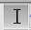 on the tool bar then click on the waveform to choose a place to start. Click and drag to create a selection, and then when you click Play, only the selection will play. When this clip is selected, use the Cut tool to remove the section.
- Copying & Pasting: Follow the same first steps as cutting. When you have a clip selected, press the Copy tool (or go to Edit > Copy) then move your cursor and click on the waveform where you want to paste. Then use the Paste tool (or Edit > Paste).
- Add Fade In & Fade Out: Click on the start of the waveform. Go to Effect > Fade In. Then click on the end of the waveform. Go to Effect > Fade Out.
- Splitting waveform into clips: Click on the waveform where you want to split it. Go to Edit > Clip Boundaries > Split. This will split the waveform into two clips. You can also click and drag to select a section of the waveform and create a new clip out of the selection following the same process.
- Moving clips: Highlight the clip you want to move. Then select the Time Shift Tool on the tool bar. Drag the clip to where you want it.
- Adding a second audio clip: You can add a second audio clip (for example, a soundtrack) by going to File > Import > Audio and selecting the file. You will now see the new waveform below the first one. On the left side, each waveform has a volume control and mute option so you can adjust the volume or listen to one track at a time. If you want to mute one of the clips, select the given clip then go to Edit > Remove Audio or Labels > Silence Audio.
- Exporting the file: When you’ve finished, save a final version of the clip in Audacity. Then click File > Export. Choose the file type you want and then click Save. Here’s a description of different file types: (http://audacity.sourceforge.net/manual-1.2/fileformats.html). The most common file type is an .MP3, but first you’ll need to download the plugin LAME (http://lame1.buanzo.com.ar/). You’re done!

Here is a link to the full manual: http://manual.audacityteam.org/o/

