
COMMUNITY EXPRESSIONS, LLC
Bringing Story to the Heart of Communities

VCF June 2013 Workshop
Effective Storytelling and Story Connecting through Social Media

Hour One Social Media Introduction

- Welcome/Agenda/Intros
- Discussion/Presentation: Why Storytelling: A Brief Review
- Exercise One: Your Social Media Story
- Discussion/Presentation: Why Social Media, An Overview
- Exercise Two: Your Social Media Landscape, A Self-Assessment
- Presentation/Discussion: Touring Our Case Study

Hour Two Blogging

- Presentation/Discussion: The When and Why of Blogs for Nonprofits
- Exercise Three: Blogging, Commenting and Mentioning
- Presentation/Discussion: Challenges and Opportunities

15-Minute Break

Hour Three Facebook and Twitter

- Presentation/Discussion: Facebook and Storytelling
- Exercise Four: A Facebook Story, Four Ways
- Presentation/Discussion: Twitter as Story Vehicle
- Exercise Five: Follow, Tweet, Retweet, Direct Message and Tag

Hour Four Building A Social Media Strategy

- Presentation: A Brief Look at Video and Image Sharing, Other Tools
- Exercise Six Matching Mission, Communications Goals, Audience, Tools
- Exercise Seven/Conclusion: Story of the Day

Workshop Materials and Resources:
http://community-expressions.com/resources-3/resources-for-vcf-storytelling-workshops/

Contact Barbara Ganley at Community Expressions, LLC:
Phone 802 989 1885 Email barbaraganley@gmail.com Twitter bgblogging
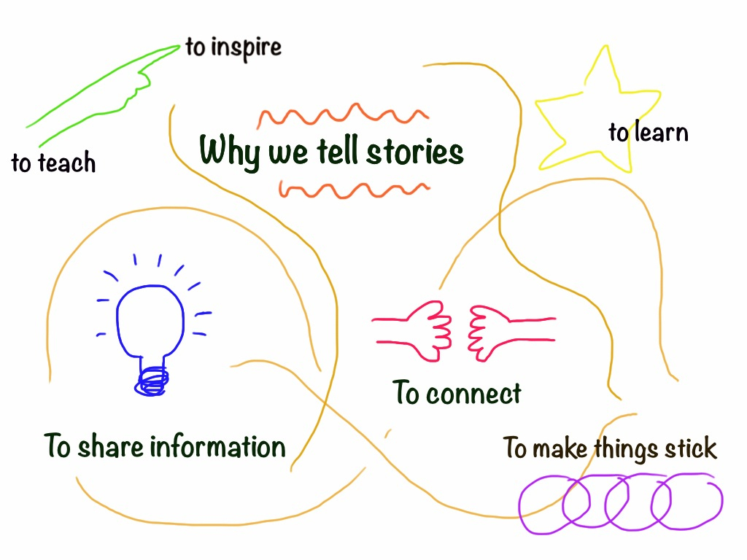

WHAT DO WE MEAN BY STORY?
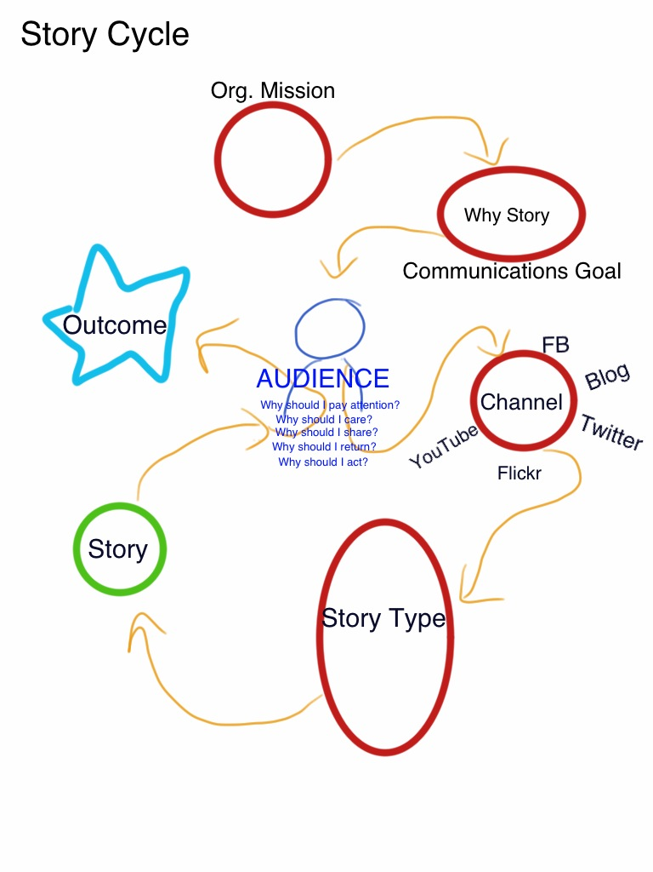

BLOGS

Platforms
Wordpress
Blogger
Tumblr

Writers
Staff, Donors, Board Members, Clients, Community Members, Outside Experts, Visitors

Post Content
Client stories, Processes, A Day in the Life, Connected Stories, Interviews

What makes us unique? What value do we offer? What’s new in the field?
What stories do we have to share with you that we hope you comment on and share with your network?

TIP: Look in your organization email correspondence for post ideas
TIP: Hold Blog Invitationals—conversations with several guest bloggers
TIP: Think about your post length and why you publish it here instead of FB

Qualities of a Good Post
Visual and Audio Elements Used Well
Relevance of the Post to Audience
Voice of the Post Matches the Audience
Engaging Subject Matter
Invitations to Conversation
Appropriate Use of Links

Frequency
Consistently! Often enough that readers want more, not so often as to inundate them and exhaust your staff. Once or twice a week.

Blogging Exercise

- Draft a Blog Story on a Large Sticky Note (100 – 200 words). Make it legible! Include notes/drawings about images you intend to include. Keep in mind the 4Cs:

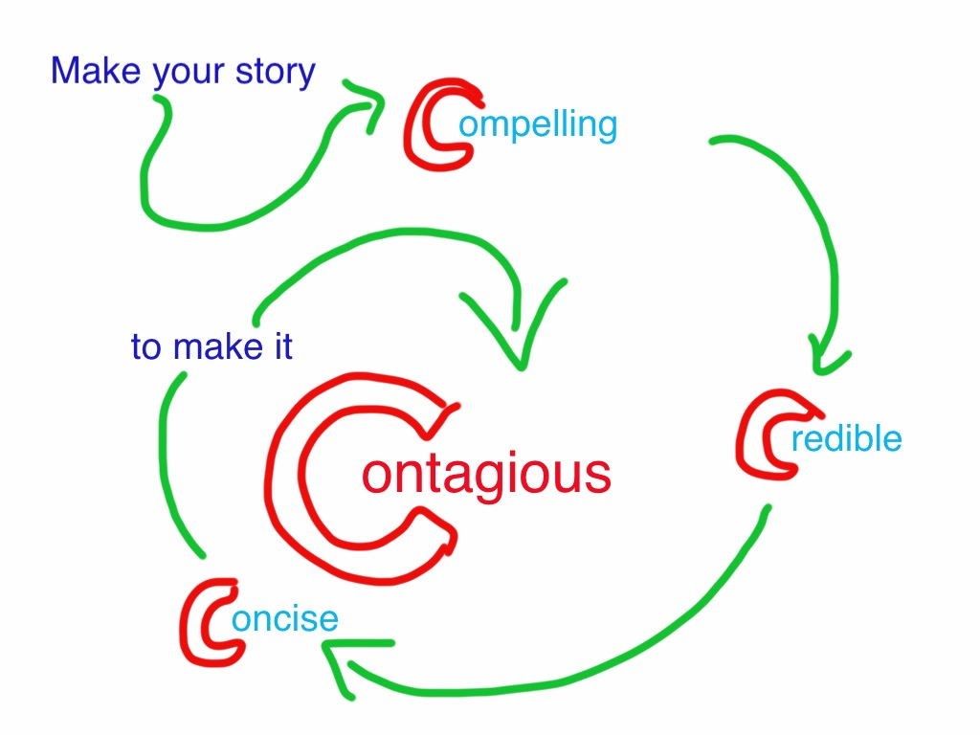

- Place all group blogposts on a large flipchart sheet.

- Read the other posts from your group and choose between the following for each. You must write at least one comment (b) and one blog post (c) in total.

- Give it a LOVE
- Write a comment (on small sticky note; attach to original post)
- Write your own blogpost in response on large sticky note. Draw a line between your post and the original.
- Nothing at all

- Read comments and posts written in response to your original and write a response (carry on the conversation).

- Compare what happened with each blogpost.

Facebook Storytelling Exercise

- Draft a Facebook Story (100 words)

- Find a Creative Commons-licensed photo on Flickr.com that could tell that same story with a text overlay. Download the image onto your computer desktop and upload it onto Pixlr.com Write the text overlay.

- Write a question or a request post that asks readers about the message/topic/subject in the above stories.

- In your small groups, give each other feedback:

- Would you be inclined to read the entire post and return to the site?
- Would you want to leave a comment? Like the post?
- Does the image draw you in? The text?
- Would you respond to the question/poll?
- Suggestions?

Twitter Exercise

- Sign up for a Twitter account if you do not have one.

- Make a tweet about the workshop, using the hashtag #VCFsm

- Find and follow other workshoppers by searching the TAG #VCFsm

- Practice tweeting by responding to tweets, retweeting, favoriting and using hashtags.

- Write at least three kinds of tweets (to convey information, to bring attention to your nonprofit, to connect, to link to others’ work)

BUILDING YOUR SOCIAL MEDIA STRATEGY

**Less can be more
**Ask “What for” then “What”
**What about the social in social media?
**What unique story do you have to tell and value to offer?

