
COMMUNITY EXPRESSIONS, LLC
Bringing Story to the Heart of Communities

The Art of Storytelling VCF June 2013 Workshop

HOUR ONE: The Story, The Telling

- Opening Storytelling Exercise

- Presentation/Discussion: The What & Why of Story and the Story Moment

- Opening Exercise, Part II: The Retelling

HOUR TWO: The Mission Story

- Presentation/Discussion: Mission Statements/Mission Stories

- Storytelling Exercise Two : Your Favorite Mission Story

- Discussion: What Makes a Great Donor Story/telling?

15 - Minute Break

HOUR THREE: The Nonprofit Story, Part Two

- Presentation/Discussion: Writing, Image and the Nonprofit Story

- Storytelling Exercise Three: Writing An Organization Story

- Critique and Discussion: The Special Challenges

HOUR FOUR: Planning A Storytelling Strategy

- Performance: Stories from the Day

- Exercise Four: Approaches to a Storytelling Strategy—Media, Channels, Story Banks

- Conclusion: Story of Today

Workshop Handout and Resources: http://community-expressions.com/resources-3/resources-for-vcf-storytelling-workshops/

To Contact Barbara Ganley at Community Expressions
Phone: 802 989 1885 Email: barbaraganley@gmail.com

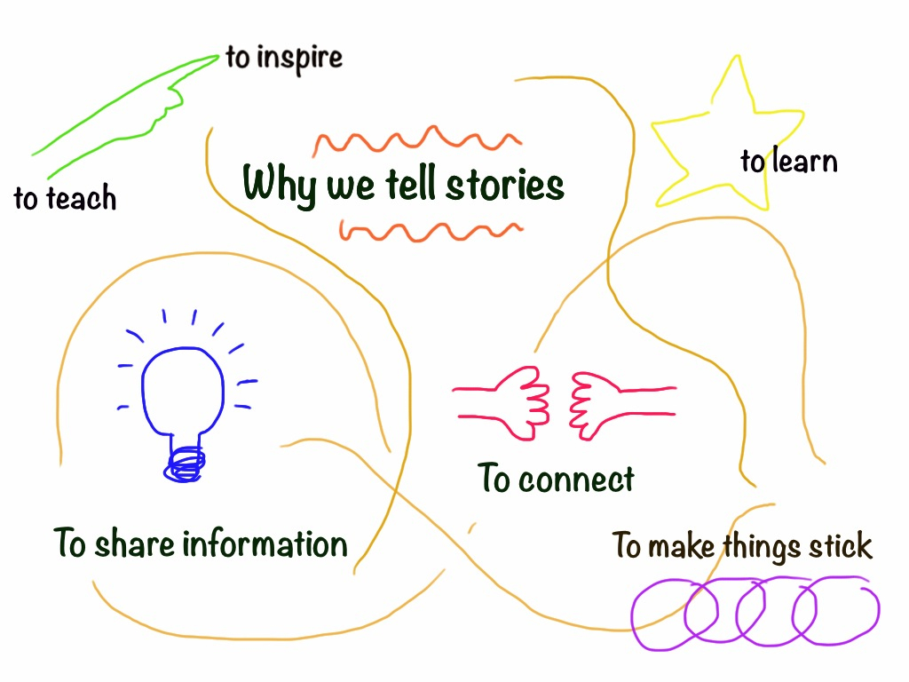

KINDS OF STORIES:

STORY ELEMENTS:

How Stories Work

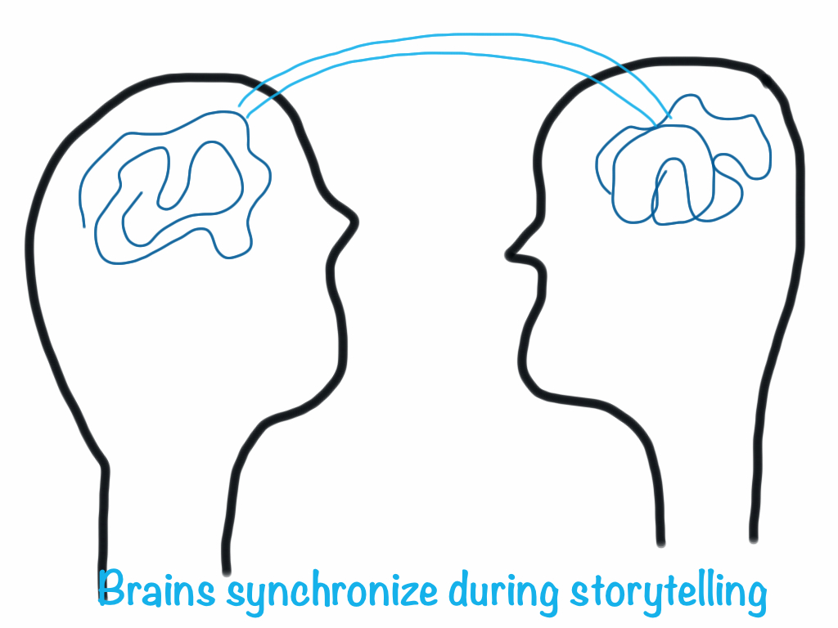
Hasson, Silbert & Stephens

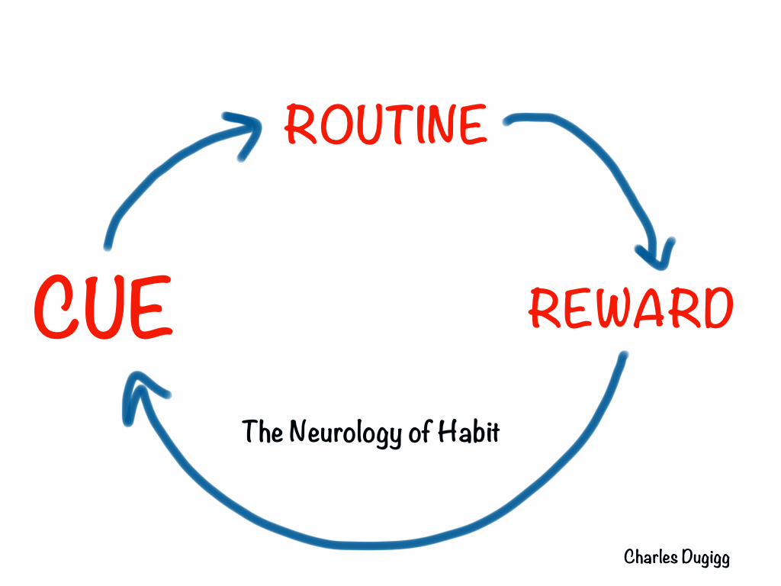

TRUST & LISTENING

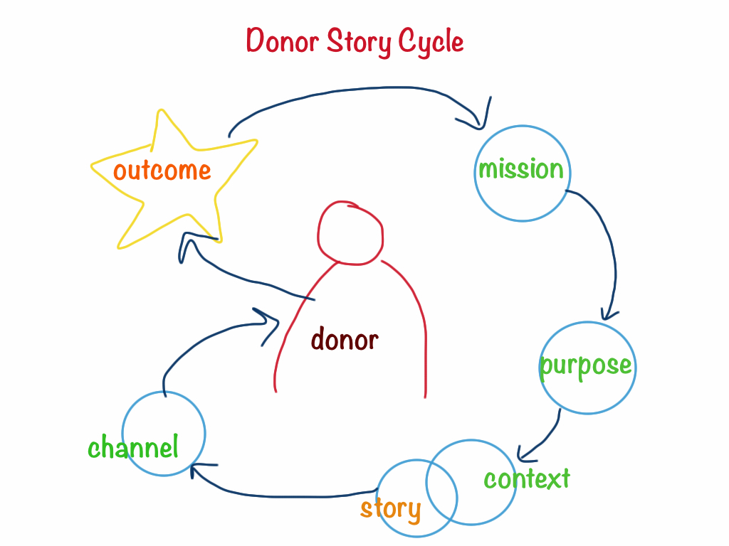

Questions Donors (And Others) Have

Why me? What relevance does this have for me? (In what way does the mission intersect with my interests, experience and expertise?)

Why should I care? (How does this satisfy my need for facts? How does it touch my heart?)

What exactly is being asked of me? (donation, participation, communication?)

Will they follow up with me? (Why should I return?) Will they evaluate the work? Will they keep me informed of developments and outcomes?

Are they looking to build a relationship or receive a one-time donation?

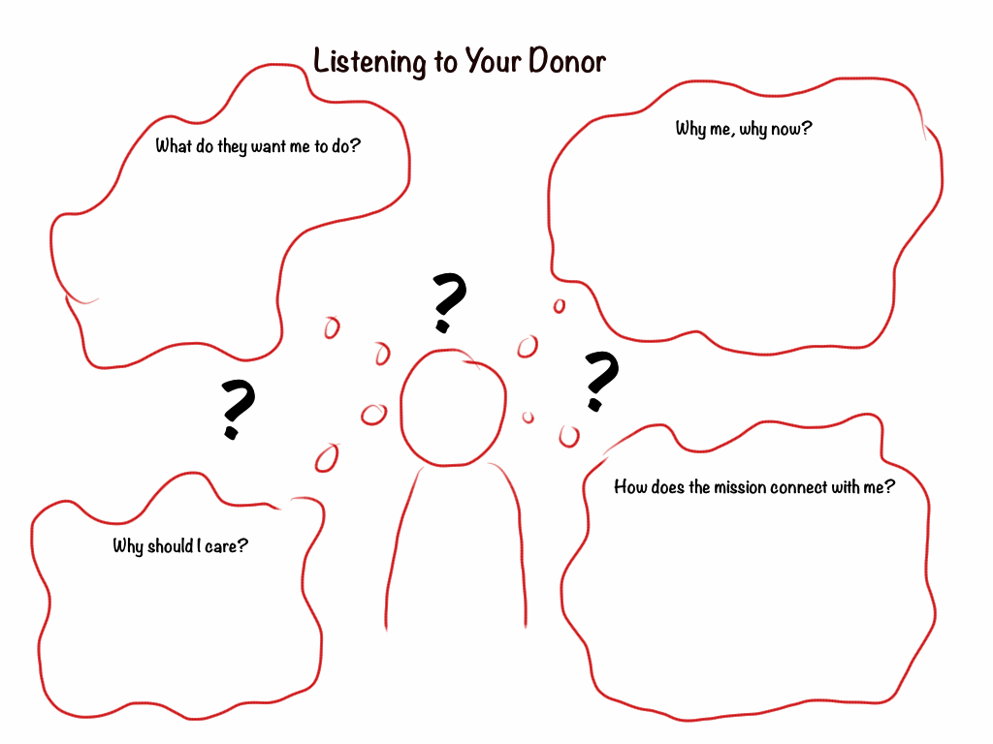

STORIES I COULD SHARE WITH THIS PERSON(S):

MISSION STATEMENTS/MISSION STORIES

Eight-word Mission Statement

VERB – TARGET – OUTCOME

“Building Confidence, Teaching Skills, Changing Lives”
(from Vermont Works for Women)

YOUR MISSION STATEMENT

_______ _______ _______ _______ _______ _______ _______ _______

Stories to Bring the Mission Statement to Life

YOUR MISSION STORY

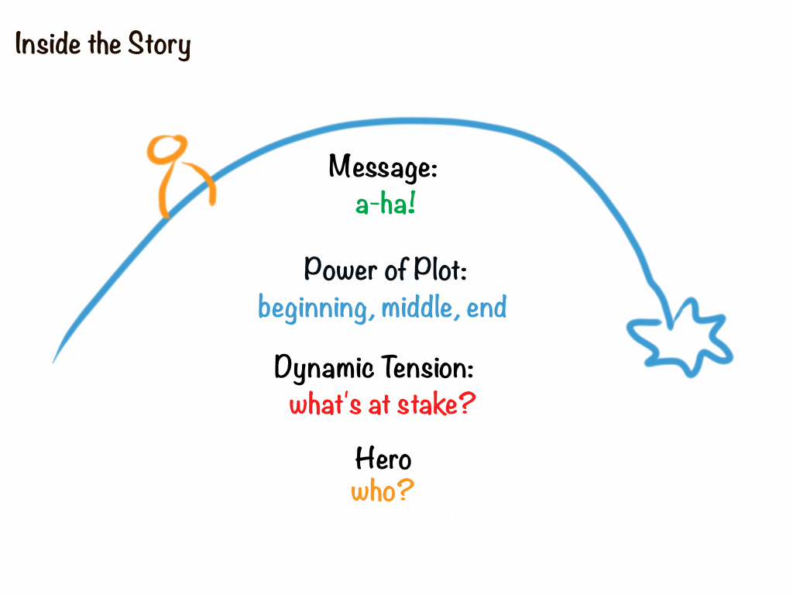

Audience:

Purpose:

Resulting Action:

Story Message:

Hero:

What’s at Stake:

Plot: Beginning/Middle/End

What Changes?

So What?

More Story Questions

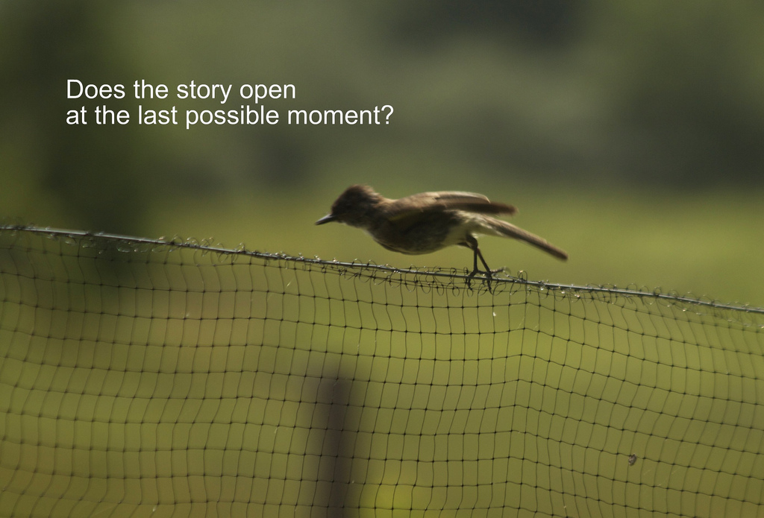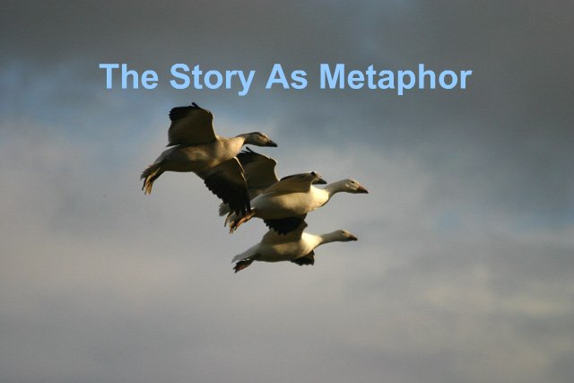

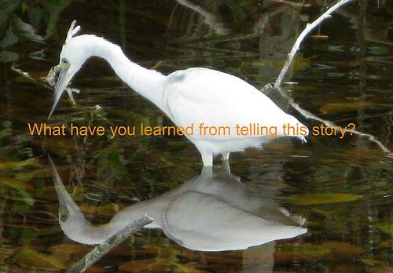

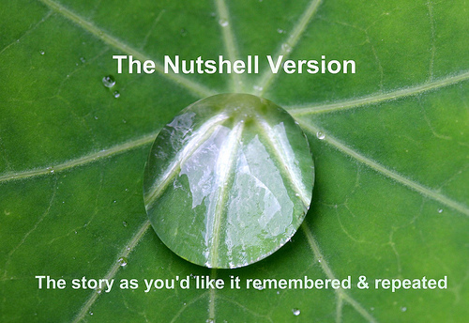

Written Version:
Visual:
Oral:

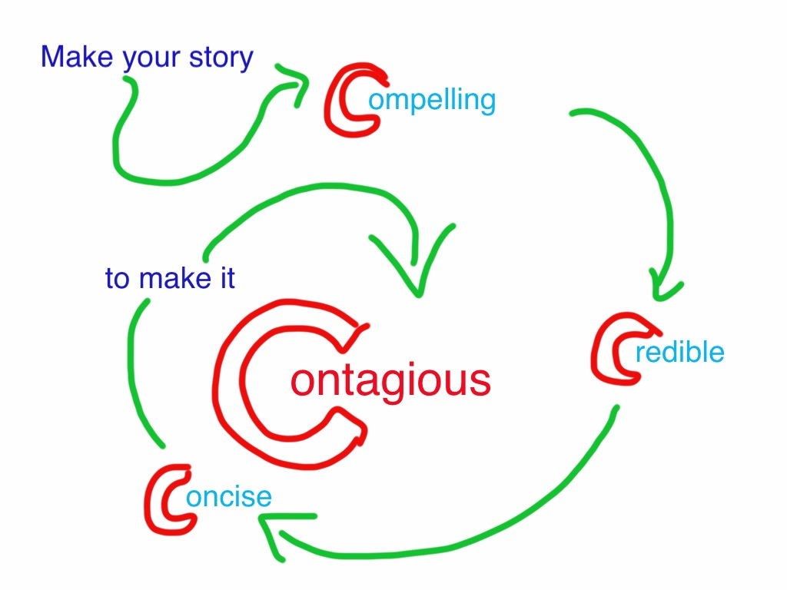

Questions and Leads To Ask for Story

*A story brings us close to an experience—we can see it; a great story brings us into the moment and makes us care. Something is at stake in a story; something happens that matters and changes something or someone

Tell me about a time when…(someone did something/was helped; something happened to change things)

Tell us about your proudest hour with the organization

Tell us about an “aha” moment, when you understood what is possible

What story would my donation make possible?

Tell the story of a ‘day in the life’ of a client.

Show us the process of something your organization does as part of its mission.

OTHERS:

Building a Storytelling Strategy
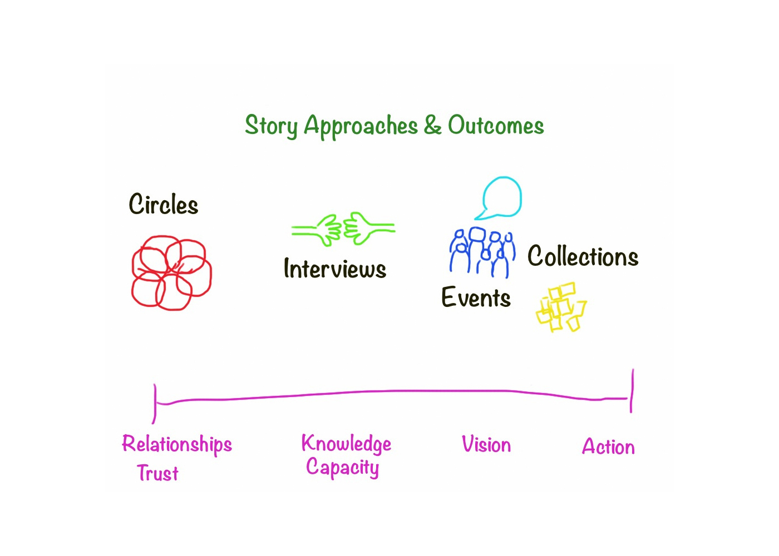

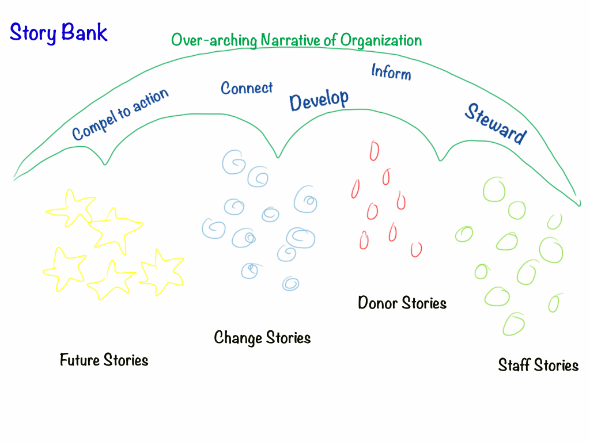

MEDIA CHOICES: WHY & WHEN

TEXT

IMAGE

AUDIO

VIDEO

MULTIMEDIA

STORY CHANNELS

ORALLY ONE-ON-ONE

ORAL PRESENTATION

NEWSLETTER

PRESS RELEASE

WEBSITE

SOCIAL MEDIA

FUNDRAISING APPEAL LETTER

POSTER

RADIO SPOT

TELEVISION INTERVIEW

ADVERTISEMENT

ANNUAL REPORT

A Sampling of Community Storytelling Activities and Events

Postcard Stories/ Walls http://wallwisher.com

Locative Stories Embedded into the Landscape

- 100 People/One Question Interviews http://fiftypeopleonequestion.com/
- Murmur-type project (http://murmurtoronto.ca/index.php)
- Story Quilt/Story Murals (drawn, painted, photographed & projected a la JR) http://jr-art.net/
- Story Benches/Story Boxes/ Story Circles/Story Art

Community Story Calendar

The Moth-type Storytelling gatherings (recorded): http://themoth.org/

The Sounds of the Community; Voices of the Community

1000 Journals-type Project http://www.1000journals.com/

StoryCorps-type Interview Project http://storycorps.org/

Day in the Life of…Project http://www.olympus-global.com/en/event/DITLA/

Digital Stories Center for Digital Storytelling: http://storycenter.org

Mobile story circles (Story walks)

OTHERS:

Developing a Storytelling Strategy

1. Why Do You Need a Storytelling Strategy?

2. What Is Your Story Timeline
Stories We Need Now, Soon, Later

3. Stock a Story Bank
Donor, Staff & Client Stories
Past, Present & Future Stories
Scenario Stories
Nutshell & Full Stories

4. Become a Storytelling Organization
Sharpen Storytelling & Gathering Skills
Add Media Capacity as Needed
Share & Gather Internal Stories
Host Story Events & Projects

