
COMMUNITY EXPRESSIONS, LLC
Bringing Story to the Heart of Communities

VCF Workshop
Telling Your Community Story

HOUR ONE: The Story, The Telling

- Opening Exercise: Our Mission, Our Stories

- Networking Exercise: The How & Why of the Nonprofit Story

- Discussion/Demonstration: The Donor Storytelling Cycle

HOUR TWO: Telling as Listening

- Collaborative Exercise: Active Listening

- Donor Profile Exercise

- What Makes a Great Donor Story/telling?

15 Minute Break

HOUR THREE: The Story—Finding, Framing, Storyboarding and Sharing

- Analyzing a Story—Frame, Teller, Arc: Discussion/Demonstration

- A Story Bank & Selection Exercise

- Finding the Full & Right Story: Nutshell & Metaphor Exercises

- Crafting the Story

HOUR FOUR: Trying it Out and Planning A Storytelling Strategy

- Performance: Sharing the Stories

- Next Steps: Taking What You Learned and Planning a Storytelling Strategy

- Reflection Story

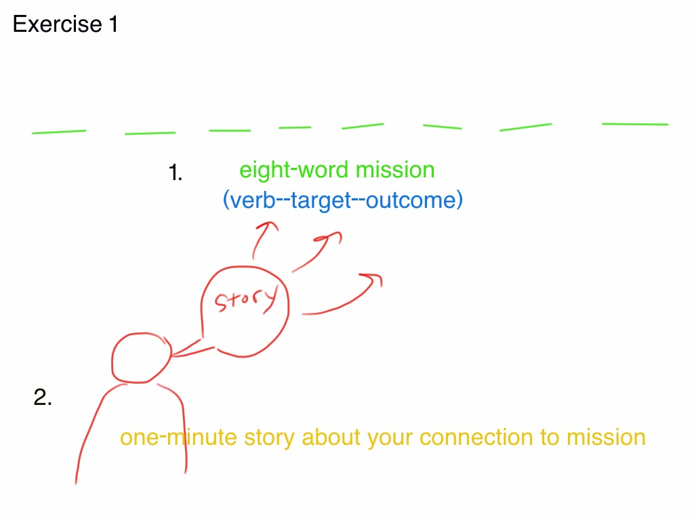

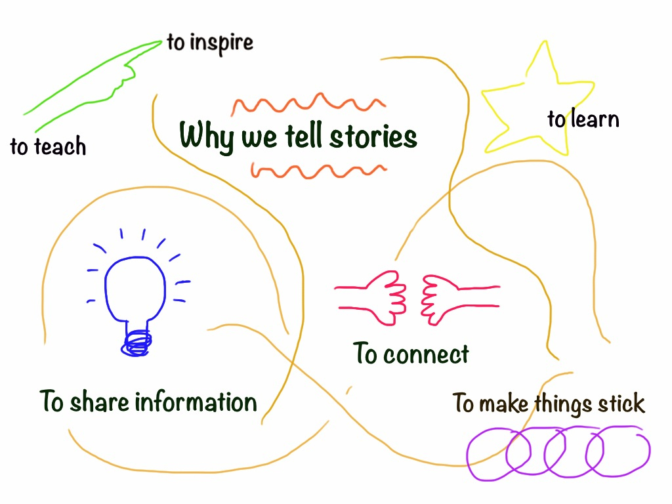

__________________________________________________________________
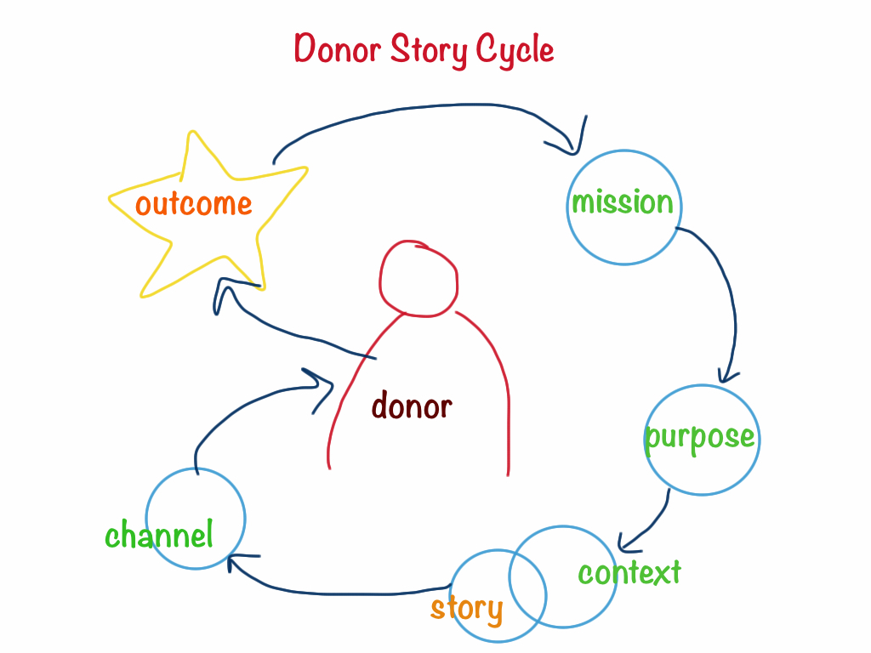

MISSION & ITS RELEVANCE TO THE DONOR

YOUR PURPOSE IN APPROACHING THE DONOR: To cultivate and strengthen relationships, to inform, to learn, to make an ask, to celebrate, to steward?

THE STORYTELLING CONTEXT: Who will tell the story, where and why?

THE BEST STORY IS THE RIGHT STORY: WHY THIS STORY NOW?

CHANNEL: What media will you use (Think about your donor & your capacity)
Text, image, audio, multimedia? Via mail, in person, online, on the phone?

OUTCOME: What action will result from the storytelling cycle?

Why We Listen & Act as We Do & What It has to do with Storytelling
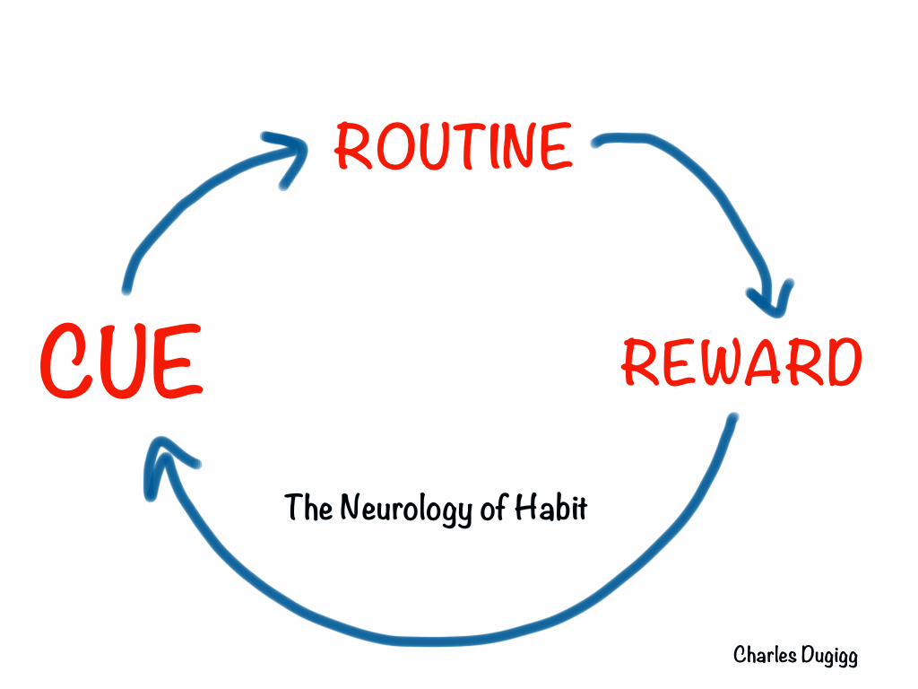
___________________________________________________

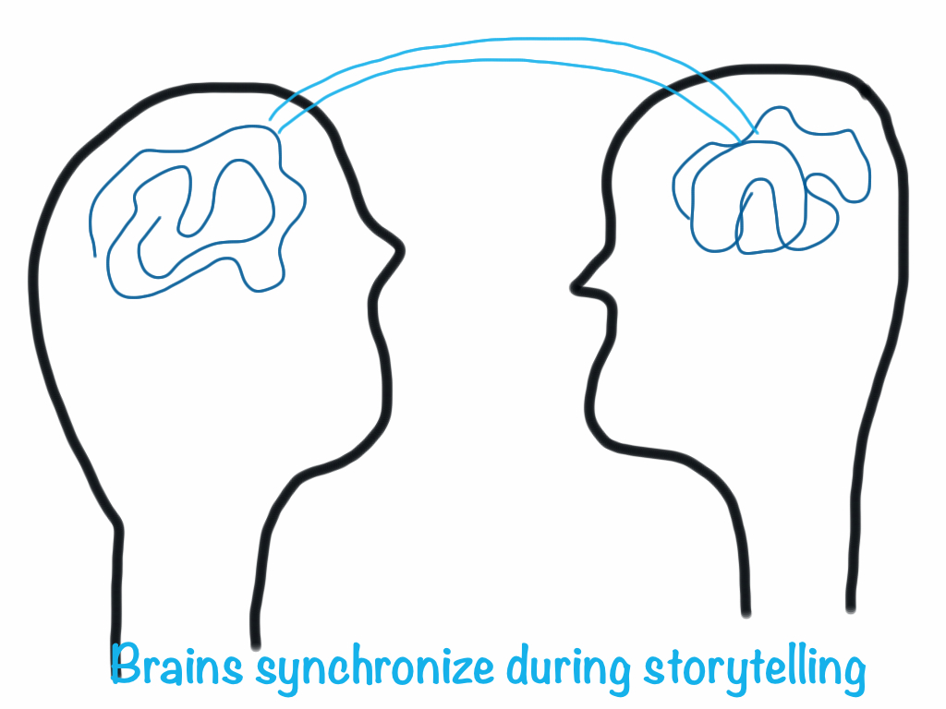
Hasson, Silbert & Stephens
_______________________________________________________________
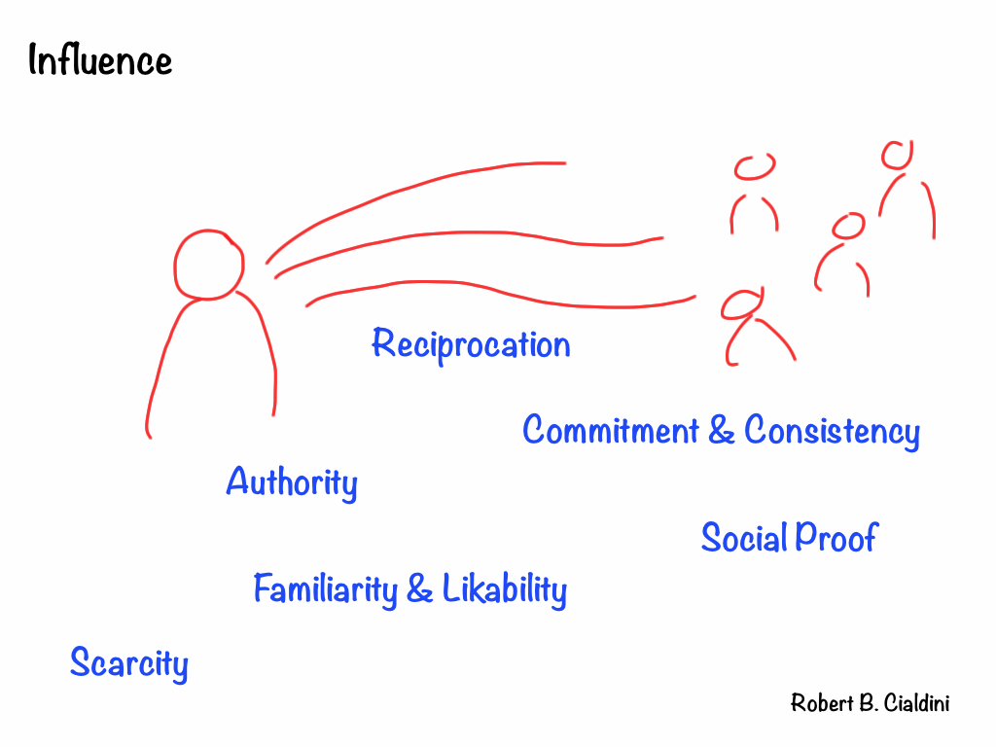

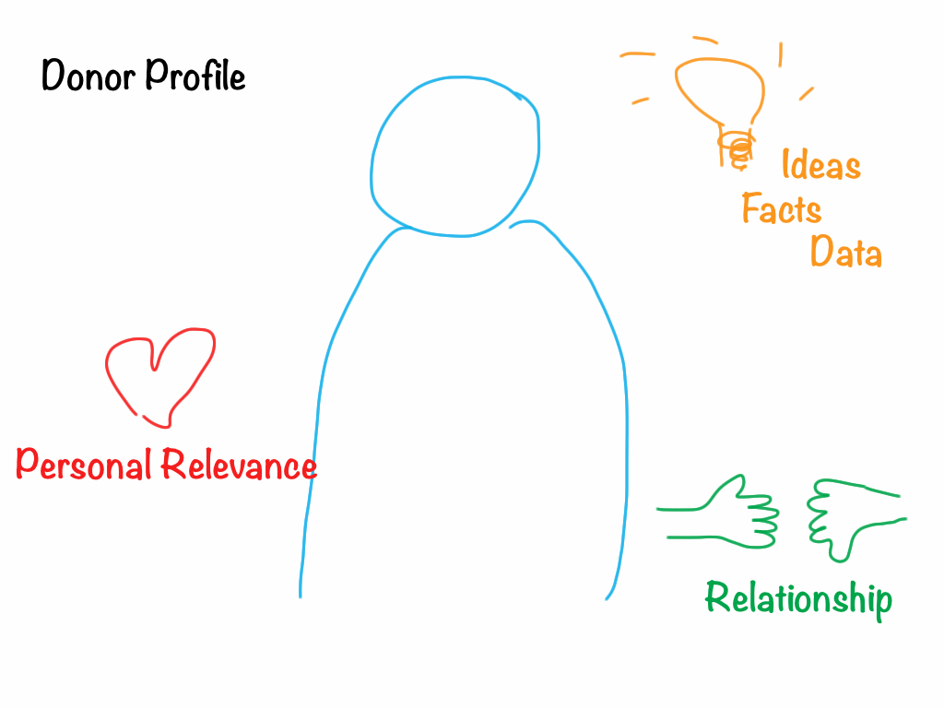Questions Donors Have

Why me? What relevance does this have for me? (In what way does the mission intersect with my interests, experience and expertise?)

Why should I care? (How does this satisfy my need for facts? How does it touch my heart?)

What exactly is being asked of me? (donation, participation, communication?

Will they follow up with me? (Why should I return?) Will they evaluate the work? Will they keep me informed of developments and outcomes?

Are they looking to build a relationship or receive a one-time donation?

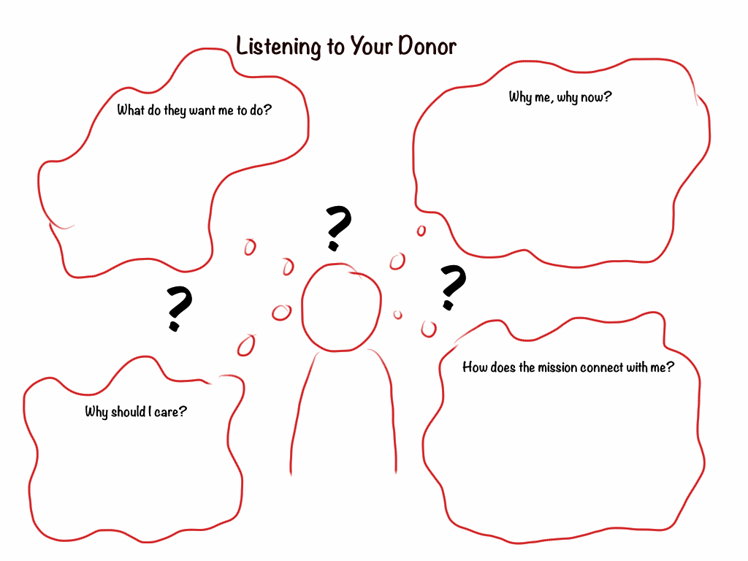 Your Donor

STORIES I COULD SHARE WITH THIS DONOR:

EXAMPLE of the RIGHT STORY at the RIGHT TIME

“Facts give stories substance. Stories give facts meaning.”
Lee LeFevre The Art of Explanation

“It takes two to story.”
Richard Kearney On Stories

Simple Story about a Simple Story

Last week, I received a last minute call from a lawyer supportive of the ACF to be at a Old Timers and Pensioner's meeting because the group was disbanding and wanted some place to spend their $35,000.
I was faced with a group of retired miners who didn't understand that as a 501c3 they could not divide the money amongst themselves. After the legal issue was resolved, the discussion began as to where the money should go....some wanted to send it to a charity out of town.
So...I told them a story. I told them about my Dad working on the hill for years, how he loved this community and wanted to give something back; how he would have enjoyed being in their boots and have the opportunity to give. I also brought up the Clark heiress and wouldn't it have been wonderful if Mr. Clark would have started a foundation in Anaconda years ago?
Anyway...the story telling worked its magic and the entire amount was given to the ACF.

THINK OF YOUR ASSERTIONS ABOUT YOUR MISSION & WHAT YOU NEED FROM THE DONOR:

For every assertion, come up with five possible stories to share that will bring that assertion to life.

The Stories We Have, The Stories We Need

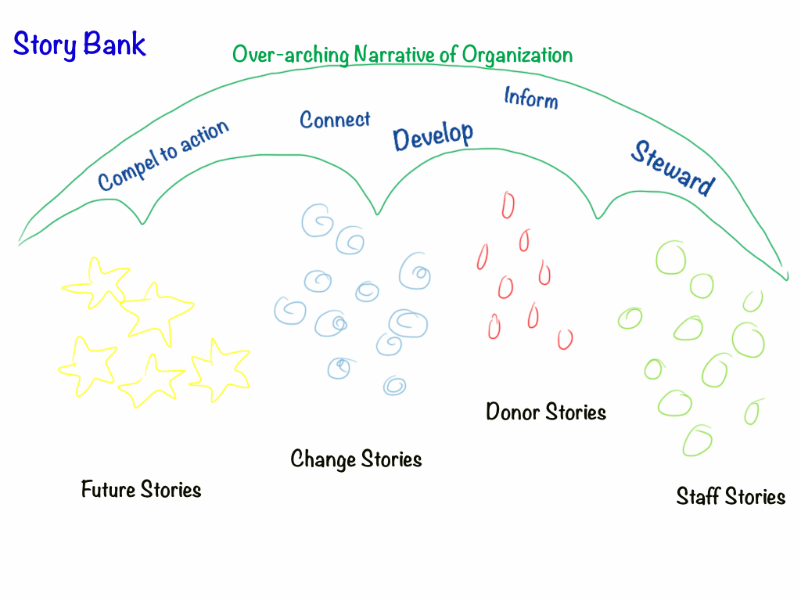

How Might You Fill Your Bank?

THE STORY: ELEMENTS

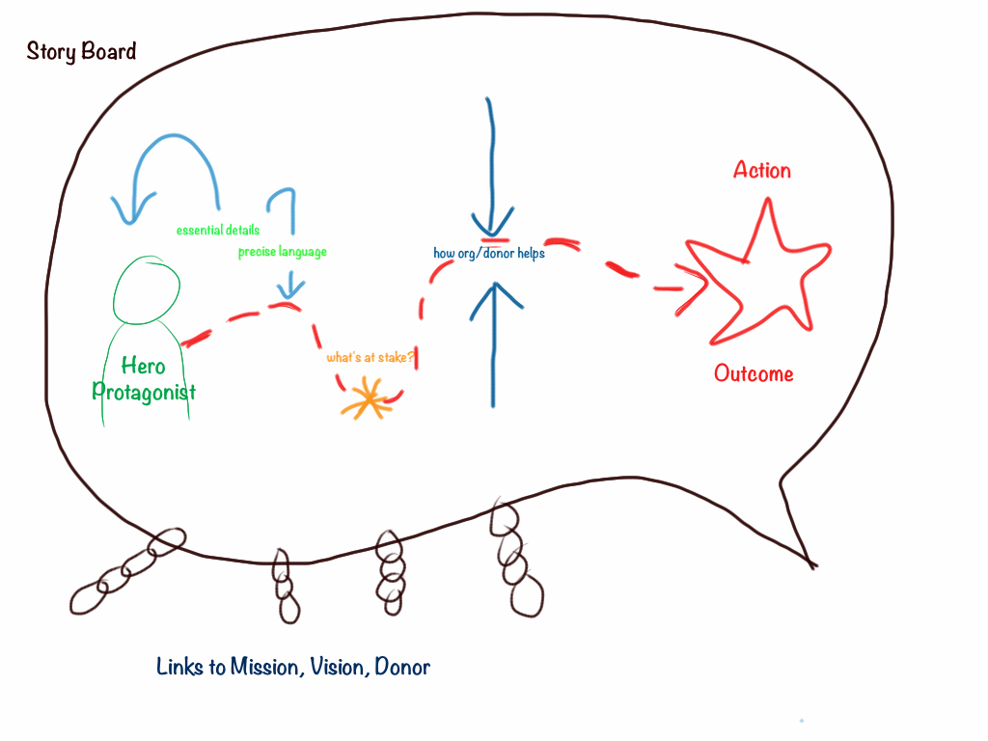
Who is the protagonist-hero? Why?
What’s at stake?
What happens? What changes? A-HA moment?
What does this have to do with the donor?
What is the action outcome?
SO WHAT? (WHY DOES THIS MATTER?)

STORYTELLER

Voice & Point of View

Connection to the Story

Connection to the Donor

Story Channel (Media & Vehicle)

STORY SHAPES

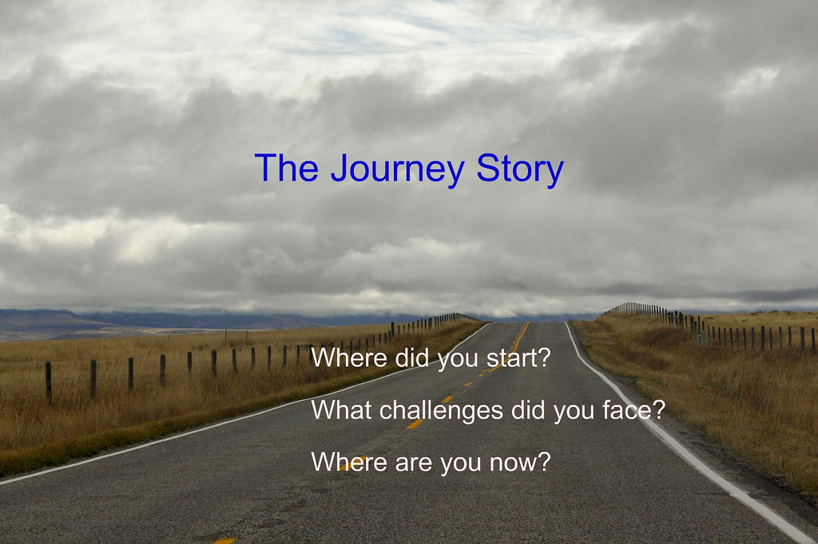

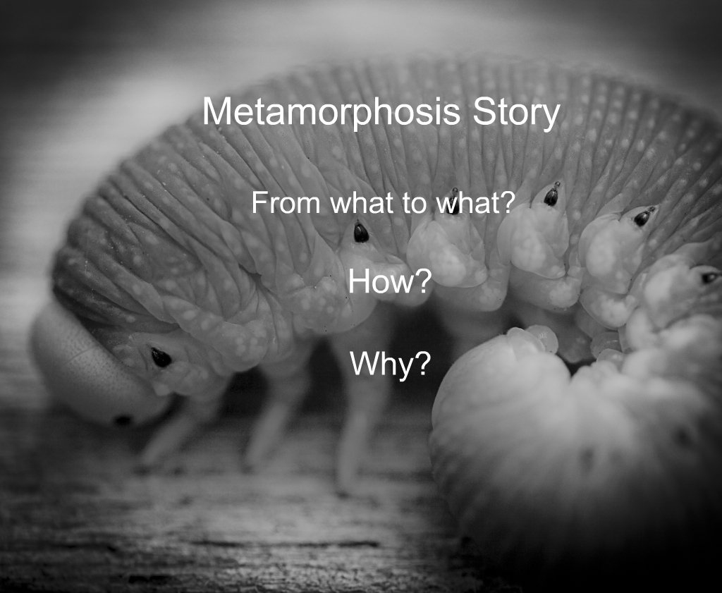

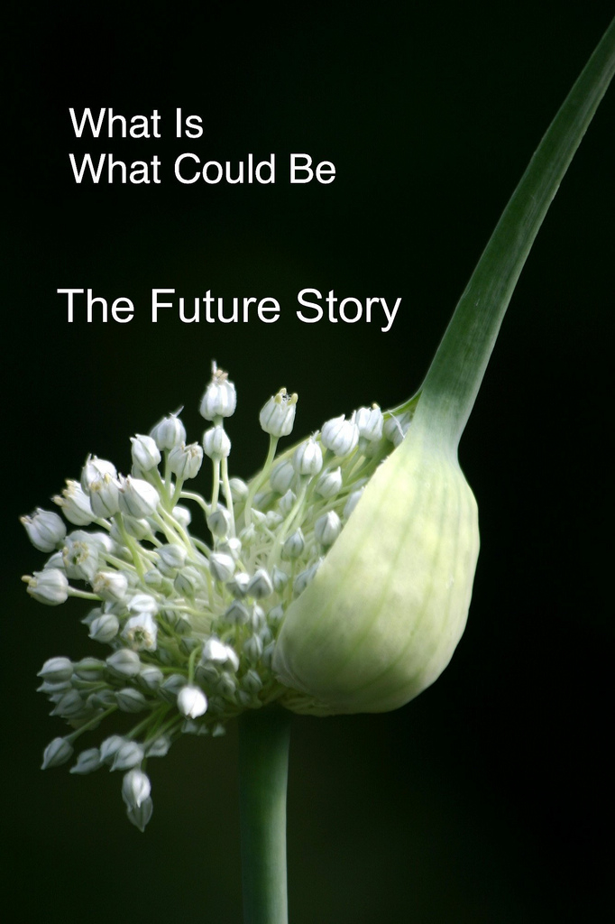

STORY ARC

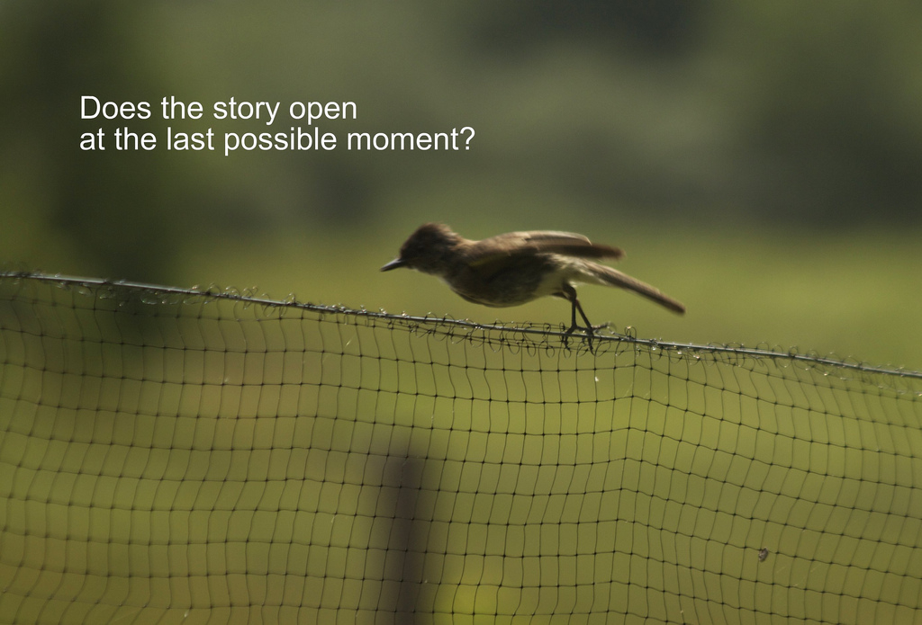

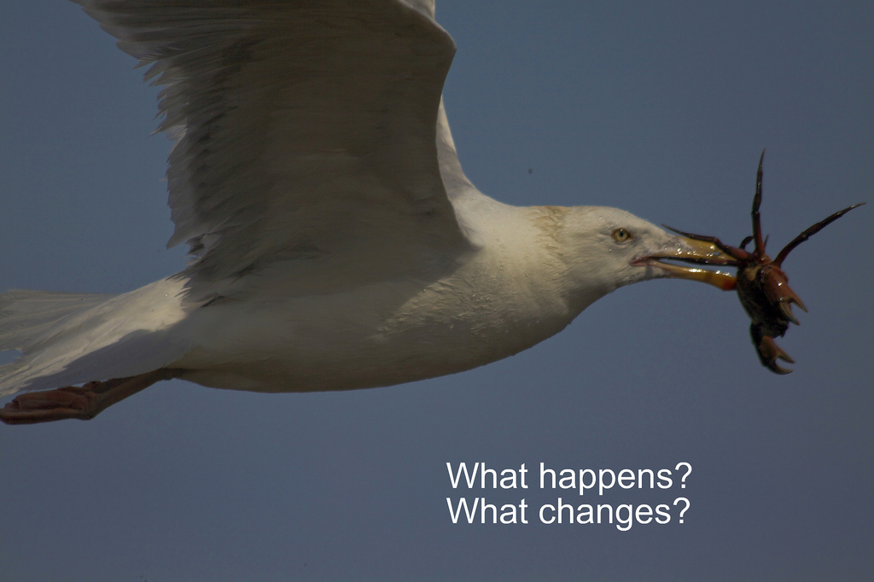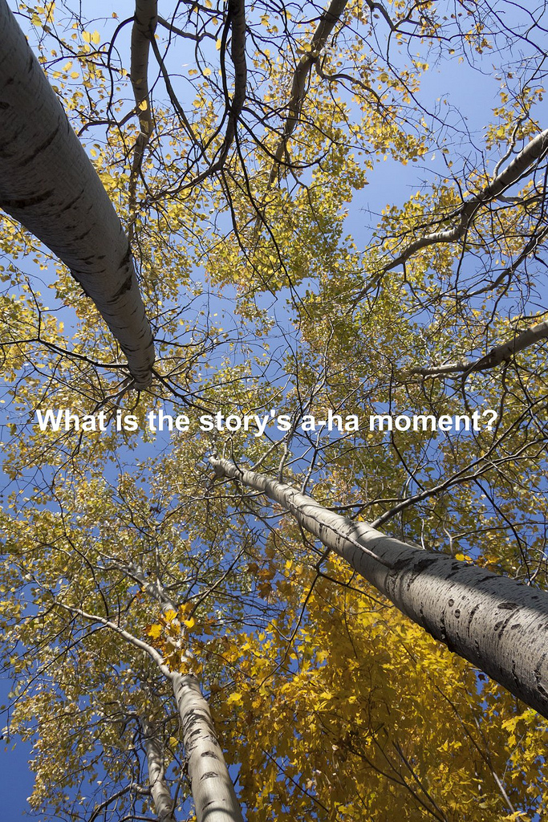

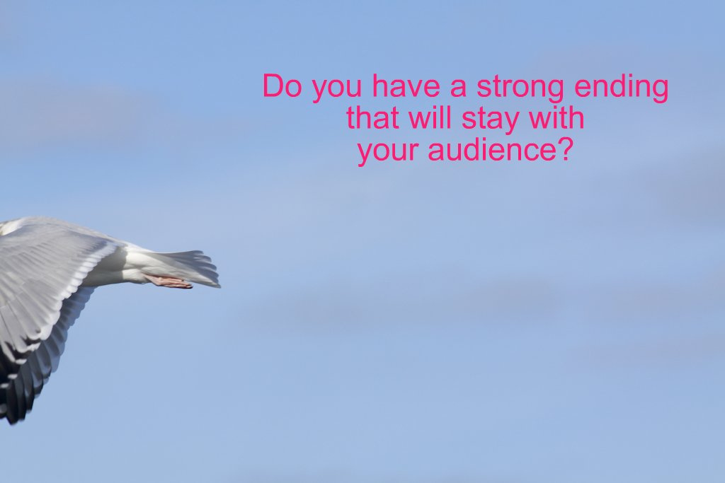

EXERCISE: THREE-SENTENCE VERSION OF YOUR STORY
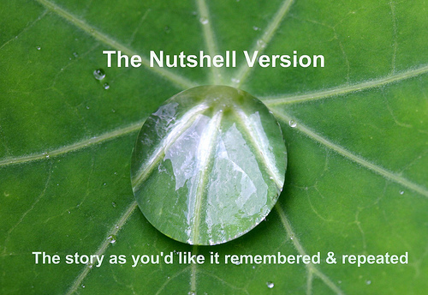

EXERCISE: METAPHORS TO RE-SEE THE STORY
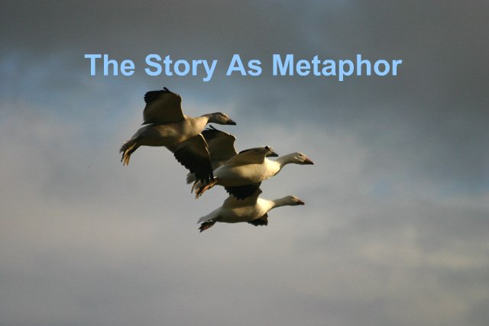

REFLECTION: WHAT DOES THIS STORY/TELLING TEACH US?
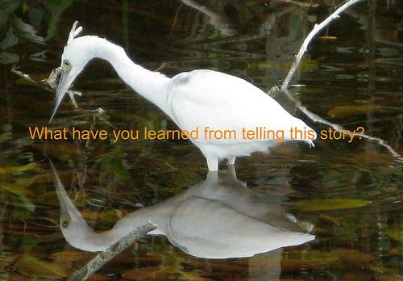

THE FULL STORY

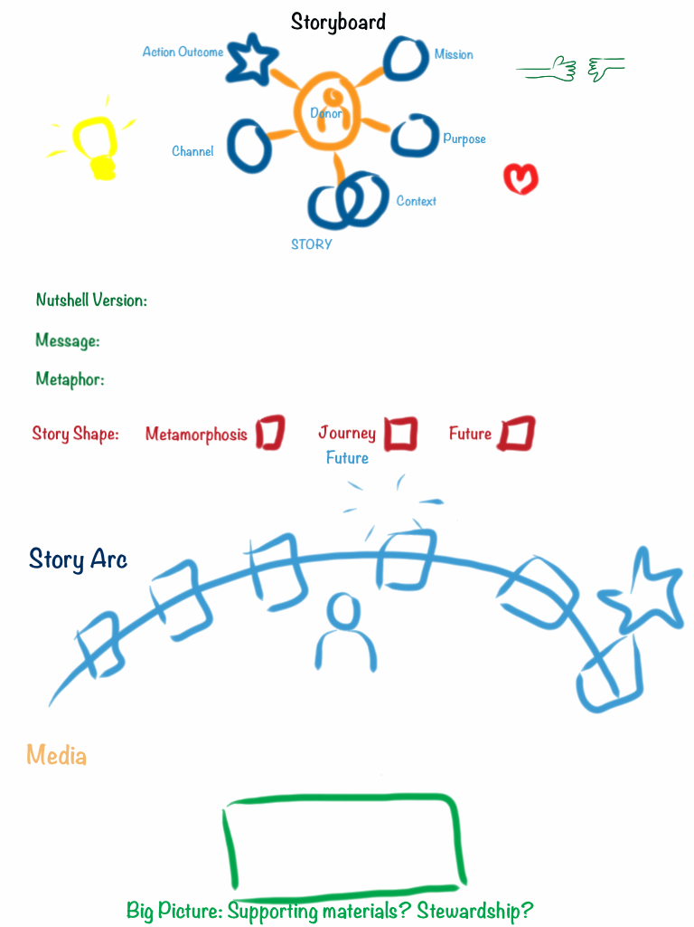

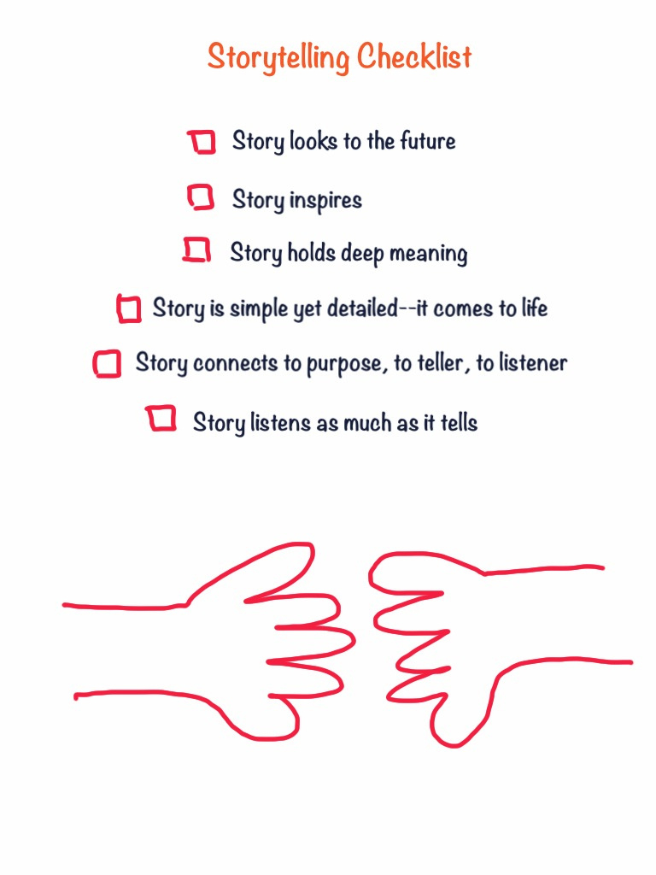

STORY GUIDE

SET-UP

Audience_________________________ Teller____________________________

Why this teller for this audience?

Purpose/Need?

Precise Outcome/Action?

CONTOURS
Frame: ☐ Journey ☐ Metamorphosis ☐ What Could Be
☐ Challenge ☐ Creativity ☐ Connection

INNARDS

Protagonist _______________________ Hero _______________________________

What’s at stake?

What change occurs?

Message?

Opening Sentence:

Closing Sentence:

Three-Sentence Version
1.______________________________________________________________________

2.______________________________________________________________________

3.______________________________________________________________________

VISUAL METAPHOR

LESSONS: What did you learn from planning this story?

WORKSHOP RESOURCES & EXAMPLES

Flickr Slide Set of the Workshop http://www.flickr.com/photos/bg/sets/72157631807325786/

Lumana Annual Report
http://lumana.org/wp-content/uploads/Lumana-2011-Annual-Report.pdf
Evelyn & Walter Haas Jr, Fund, Ernesto Pepito, http://www.haasjr.org/what-were-learning/stories/ernesto
Mind Melding & Conversation http://news.sciencemag.org/sciencenow/2010/07/mind-meld-enables-good-conversat.html?rss=1
Nature Conservancy Stories http://www.nature.org/ourinitiatives/habitats/forests/howwework/wildfire-journal.xml?s_intc=topstories
Digital Naturalist http://www.thedigitalnaturalist.com/

Community Expressions http://community-expressions.com/
(Links to Examples, Resources, Tools and Barbara’s White Paper on storytelling)
Link to this hand-out: http://community-expressions.com/resources-3/

To Contact Barbara
Phone: 802 989 1885
Email: barbaraganley@gmail.com

A Sampling of Community Storytelling Activities and Events

Postcard Stories Blank postcards & bulletin boards & online http://wallwisher.com

Locative Stories Embedded into the Landscape

- 100 People/One Question Interviews http://fiftypeopleonequestion.com/
- Murmur-type project (http://murmurtoronto.ca/index.php)
- Story Quilt/Story Murals (drawn, painted, photographed & projected a la JR) http://jr-art.net/
- Story Benches/Story Boxes/ Story Circles/Story Art

Community Story Calendar

The Moth-type Storytelling gatherings (recorded): http://themoth.org/

The Sounds of the Community Story Collage

1000 Journals-type Project http://www.1000journals.com/

StoryCorps-type Interview Project http://storycorps.org/

Day in the Life of…Project http://www.olympus-global.com/en/event/DITLA/

Digital Stories Center for Digital Storytelling: http://storycenter.org

Mobile story circles (Story walks)

Developing a Storytelling Strategy

1. Articulate Why You Need a Storytelling Strategy

2. Determine Story Timeline
Stories We Need Now, Soon, Later

3. Stock a Story Bank
Donor, Staff & Client Stories
Past, Present & Future Stories
Metamorphosis, Journey & What Could Be Stories
Nutshell & Full Stories

4. Become a Storytelling Organization
Sharpen Storytelling & Gathering Skills
Add Media Capacity as Needed
Share & Gather Internal Stories
Host Story Events & Projects

